ACKNOWLEDGMENT

We would like to express my deepest gratitude to Ms. Vaishnavi Sharma, my project supervisor, whose unwavering support and expertise were instrumental in the successful completion of this hand sign recognition project. Vaishnavi mam’s guidance, insightful feedback, and encouragement throughout the project have been invaluable. We are also thankful to Department of computer Science Faculties and all lab stab members for providing the necessary resources and facilities that enabled us to conduct this research effectively. We also wish to express our heartfelt gratitude to Almighty for his blessings, guidance, and grace, which have sustained us and provided clarity throughout this project. Additionally, We extend our sincere appreciation to our family and friends for their unwavering support and encouragement.

Table of Contents

1. INTRODUCTION 11

1.1 Problem 11

1.2 Sign Languages : 12

1.3 Sign Recognition Techniques : 12

1.4 Objective and Motivation : 12

1.5 Structure Of Report 13

2. PROJECT SCOPE 15

3. LITERATURE SURVEY 16

3.1 Sensor-Based Approaches 16

3.2 Vision-Based Approaches 17

3.3 Deep Learning Revolution 17

3.4 Hybrid Approaches and Attention Mechanisms 17

3.5 Challenges and Future Directions 18

4. TOOLS AND TECHNIQUES 22

4.1 Software Parts 22

4.2 Libraries 23

4.2.2 PANDAS: 23

4.2.3 OPEN CV – (CV2) : 24

4.2.4 OS (OPERATING SYSTEM) : 24

4.2.5 PICKLE : 25

4.2.6 MEDIAPIPE : 26

4.2.7 SCIKIT LEARN : 29

5. BACKGROUND PRINCIPLES 32

5.1 Data Preprocessing 32

5.1.1 Data cleaning: 33

5.1.2 Data integration: 34

5.1.3 Data Transformation: 35

5.1.4 Data reduction: 36

5.1.5 Feature Selection and Feature Extraction: 37

5.2 Machine Learning Techniques 38

5.2.1 Supervised Machine Learning : 39

5.2.2 Unsupervised Machine Learning 41

5.2.3. Semi-Supervised Learning 42

5.2.4 Reinforcement Machine Learning 43

5.3 Classification Algorithms 44

5.3.1 KNN [K-NEAREST NEIGHBORS] : 45

5.3.2 DECISION TREE : 46

5.3.3 SVM [SUPPORT VECTOR MACHINE] : 48

5.3.4 RANDOM FOREST : 52

5.3.5 NAÏVE BAYES : 54

5.3.7 BAGGING : 57

5.3.8 BOOSTING : 58

5.3.9 ADABOOST : 60

5.4 Hyper parameter tuning 62

6. METHODOLOGY 63

6.1 Preprocesing 63

6.1.1 Resize: 63

6.1.2 Color Conversion: 63

6.1.3 Segmentation: 64

6.1.4 Normalization: 64

6.2 Attribute Selection 65

6.2.1 Landmark Identification: 65

6.2.2 Feature Extraction: 66

6.3 Model Training 67

6.3.1 Feature Extraction and Preparation : 67

6.3.2 Handling Multiple Hands with Padding : 67

6.3.3 Test-Train Split : 67

6.3.4 Model Training : 67

6.4 Testing 68

6.5 Performance Measurement 68

6.5.1 Performance metrics : 68

6.5.2 Comparison of Results: 69

6.5.3 Cross-Validation: 70

6.6 Model Selection 70

6.7 Real time Recognition 71

7. DATASET 72

7.1 ISL Dataset from Kaggle 72

7.2 Custom Dataset 73

7.2.1 Alphabet Classes: 73

7.2.2 Number Classes: 73

7.3 Dataset Characteristics 73

8. IMPLEMENTATION 75

8.1 Data Collection 75

8.2 Hand Landmarks Extraction and Dataset Creation 77

8.3 Model Training 79

8.4 Real-time Prediction 82

9. TESTING 85

9.1 Train-Test Split : 86

9.2 KNN Model : 89

9.3 Decision Tree 90

9.4 SVM : 91

9.5 Random Forest : 92

9.6 Naïve Bayes : 93

9.7 Bagging 94

9.8 Adaboost 95

9.9 Real Time Recognition 96

10. RESULT AND DISCUSSION: 97

Best Algorithm : 100

11. CONCLUSION 101

12. REFERENCES : 102

**List of Figures**

Figure 1.1 Hand sign through camera 16

Figure 1.2 Graphs for accuracy vs models and model vs no. of paper 18

Figure 2 Pandas dataframe 24

Figure 3 Image to numpy array 24

Figure 4 OS module 25

Figure 5 pickle method in python 26

Figure 6 Mediapipe 27

Figure 7 output of mediapipe 28

Figure 8 Regression 29

Figure 9 preprocessing 29

Figure 10 clustering 30

Figure 11 classification 30

Figure 12 model selection 30

Figure 13 dimentionality reduction 30

Figure 14 Data preprocessing 33

Figure 15 data integration 35

Figure 16 data transformation 36

Figure 17 data reduction 37

Figure 18 Feature selection 38

Figure 19 Types of machine learning 39

Figure 20 supervised learning 40

Figure 21 Unsupervised machine learning 41

Figure 22 semi supervised 42

Figure 23 reinforcement learning 43

Figure 24 KNN 45

Figure 25 decision tree 46

Figure 26 Example for entropy 47

Figure 27 Impurity Criterion 47

Figure 28 Linear and non-Linear SVM 48

Figure 29 svm optimal function 49

Figure 30 SVM kernel example 49

Figure 31 random forest 52

Figure 32 random forest 53

Figure 33 naive bayes type 55

Figure 34 Ensemble learning 56

Figure 35 bagging 57

Figure 36 Boosting 58

Figure 37 boosting work 59

Figure 38 adaboost 60

Figure 39 adaboost 61

Figure 40 hyperparameter tuining 62

Figure 41 Resizing image (100X100) 64

Figure 31 RGB of image 64

Figure 30 Normal image(BGR) 64

Figure 42 Segmentated portion of image 64

Figure 43 Landmarks using mediapipe 66

Figure 44 Classification Report 69

Figure 45 K-Fold 70

Figure 46 Comparison of result example 70

Figure 47 Real time recognition 71

Figure 48 kaggle dataset 72

Figure 49 Custom dataset 74

Figure 50 Real time recognition 96

Figure 51 results before tuning 97

Figure 52 result after tunning 98

**List of Table**

Table 1 Literature survey 19

Table 2 Tools and techniques 20

# 1. INTRODUCTION

## 1.1 Problem

Listening and speaking are natural abilities of humans. Unfortunately, there are many people who do not have these abilities and cannot easily communicate with others. The World Health Organization stated that approximately 70 million people in the world are deaf-mutes. A total of 360 million people are deaf (GEEKS, n.d.), and 32 million of these individuals are children. Also, by 2050, it is expected that one in every four people will face some degree of hearing loss [1].

One of the main problems that deaf-mutes suffer from is communicating with others. Reliance on lip-reading and using sign language interpreters are two solutions for communication between deaf-mutes and non-deaf-mutes. However, lip-reading, in general is not very much useful as it require professional training and experience. In addition, the usage of sign language interpreters is very costly some what from 3 lakhs to 7 lakhs per annum . Moreover, learning sign language is difficult for many people because of the time required to learn it and the need for professional training. Therefore, communication between the two parties remains a challenge that needs to be addressed. Thus, more attention is needed by information system/information technology (IT) researchers and AI ML experts to solve this two-way communication problem.

Multiple studies have been proposed to solve the problem of communication between deaf-mutes and non-deaf-mutes. Numerous systems have also been developed using sensors, image processing, and smartphones to facilitate communication between the two parties. However, most of these systems are limited to one direction of communication from the deaf-mute to non-deaf-mute people and not vice versa. Hand sign recognition by using Machine learning techniques is one of the efficient and cheaper way to solve this communication gap between these two parties. By using this not everyone required the professional knowledge of sign languages.

## 1.2 Sign Languages :

Today, there are more than 300 different sign languages in the world, spoken by more than 72 million deaf or hard-of-hearing people worldwide.In the United States, ASL has become the dominant sign language among the deaf and hard-of-hearing communities. Today, ASL is used by more than a million people **(National Geographic, n.d.).**  In India we use ISL (Indian Sign Language) for teaching and professionally communicating with deaf and dump people. Like Other sign languages ISL also have its own literature in the form of alphabates, numbers, daily usage words etc. Sign language use hand gestures as well as face expressions. Complex words have complexity in both expressions. Professional training required to understand the official sign languages.

## 1.3 Sign Recognition Techniques :

Sign language recognition is based on two fundamental sensing techniques; vision-based and glove-based . In glove-based technique, a number of sensors attached to signers are used to capture the movement, position, direction and speed of the hand and fingers. Researchers have used sensors such as data gloves[2]. Although these studies achieved excellent results, it is generally expensive and not practical for daily life usage. On the other hand, in case of vision-based techniques, sign recognition is performed employing images of hand movements taken with the help of a single camera. Not only the vision-based technique is easier but also it has relatively lower computational cost. For the vision-based technique, image processing is used to classify them based on the features. We can then use Machine learning or Deep learning to achieve this task

## 1.4 Objective and Motivation :

Our primary objective is to design and implement a hand sign recognition system capable of accurately identifying and interpreting a wide range of hand gestures. This involves developing algorithms and models that can effectively analyze input data, such as images or videos of hand gestures by extracting their frames , and classify them into predefined categories and then apply Machine learning techniques on them. As this technique is less computationally expensive than the glove based technique this motivates us to make a cheaper and effective model which can deal with this gap of communication and accessible to common man.

## 1.5 Structure Of Report

Chapter 1: Introduction

This chapter introduces the problem of communication barriers faced by hearing-impaired individuals and outlines the project's goal to develop a hand gesture recognition system to bridge this gap.

Chapter 2: Project Scope

This chapter details the key aspects of the project, including data collection, model training, testing, and real-time implementation of the hand gesture recognition system.

Chapter 3: Literature Survey

This chapter reviews existing research on hand gesture recognition systems, highlighting different approaches, challenges, and advancements in the field.

Chapter 4: Tools and Techniques

This chapter lists the software tools and libraries used in the project, including Python, MediaPipe, OpenCV, and Scikit-learn.

Chapter 5: Background Principles

This chapter explains fundamental concepts and techniques used in the project, such as data preprocessing, machine learning, classification algorithms, and hyperparameter tuning.

Chapter 6: Methodology

This chapter outlines the step-by-step methodology employed to develop the hand gesture recognition system, including data collection, feature extraction, model training, testing, and real-time implementation.

Chapter 7: Dataset

This chapter describes the datasets used in the project, including the ISL dataset from Kaggle and the custom dataset created for improved model performance.

Chapter 8: Implementation

This chapter provides detailed descriptions of the code implementation for each stage of the project, including data collection, landmark extraction, model training, and real-time prediction.

Chapter 9: Testing

This chapter presents the results of testing the implemented system, including performance evaluation with various metrics and algorithm comparison.

Chapter 10: Results and Discussion

This chapter analyzes the results obtained from testing, highlighting the performance of different models, identifying the best-performing algorithm, and discussing their strengths and limitations.

Chapter 11: Conclusion

This chapter summarizes the project's achievements, including the successful development of a hand gesture recognition system with high accuracy and real-time capabilities.

# 2. PROJECT SCOPE

* The scope of the hand sign recognition project encompasses the development of a robust and accurate system capable of identifying and interpreting various hand signs in real-time.
* This project will involve collecting and creating a comprehensive dataset of hand signs, pre-processing images or video frames, and leveraging machine learning techniques, particularly deep learning models, to train and validate the recognition algorithms.
* Key components include designing an user interface for real-time interaction, ensuring the system's adaptability to different lighting conditions and backgrounds, and implementing efficient algorithms to achieve high accuracy and low latency.
* The ultimate goal is to create a user-friendly application that can be utilized in various domains such as communication for the hearing impaired, human-computer interaction, and gesture-based control systems.
* This project will also include testing phases, performance evaluations, and potential integration with other technologies to enhance its functionality and accessibility.
* However, our study also encountered several challenges inherent to the dataset and limitations of the models.
* The dataset itself posed challenges due to variations in hand gesture styles and inconsistencies in character shapes, leading to difficulties in accurate classification, especially for characters with similar visual patterns.
* Additionally, the limited size of the dataset constrained the models' ability to generalize effectively to unseen data, potentially affecting their performance in real-world applications.

# 3. LITERATURE SURVEY

* Numbers of research took place in this domain of hand sign recognition and with time researchers came with their optimal solutions. These solutions are based on different techniques and we can differentiate them on the basis of datasets, Machine Learning Algorithm, Image preprocessing, Some gadgets like glove, Sign language type like Russian, Indian, American etc.
* The camera vision based sensor is a common, suitable and applicable technique because it provides contactless communication between humans and computers[3].
* A simple diagram of the camera vision-based sensor for extracting and identifying hand gestures is presented as below

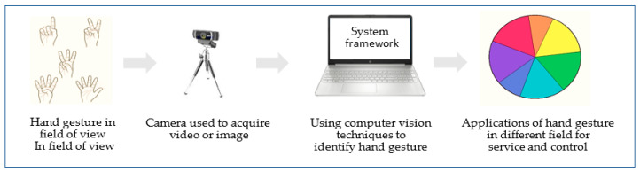

Figure 1 Hand sign through camera

* Automatic Sign Language Recognition (SLR) has emerged as a crucial area of research, driven by the need to bridge the communication gap between the deaf and hearing communities. Existing approaches can be broadly categorized into two main paradigms: sensor-based and vision-based systems.

## 3.1 Sensor-Based Approaches

Early SLR systems relied heavily on sensorbased technologies, such as data gloves equipped with sensors to capture hand movements and finger configurations . These systems offered high accuracy due to the precise capture of hand kinematics. However, their widespread adoption was hindered by the cumbersome nature of the equipment, high cost, and limitations on natural movement [4].

## 3.2 Vision-Based Approaches

With advancements in computer vision and machine learning, vision-based approaches have gained prominence due to their non-intrusive nature and cost-effectiveness. These systems typically involve image or video capture of signers, followed by a series of processing steps:

Hand Detection and Tracking: Various techniques are employed to detect and track the hands within the image or video frames. Traditional methods utilize skin color modeling [5], [6], while more recent approaches leverage deep learning-based object detection models such as Faster R-CNN, YOLO, and EfficientDet .

Feature Extraction: Once the hands are localized, features are extracted to represent the hand shape and movement. These features can be based on hand shape contours, distances between fingertips, angles between joints, or deep learning-based embeddings [5], [7], [8].

Classification: Finally, classifiers like Support Vector Machines (SVM), Hidden Markov Models (HMM), and various deep learning architectures are employed to categorize the extracted features and recognize the corresponding signs [9], [10].

## 3.3 Deep Learning Revolution

Deep learning has significantly impacted the field of SLR, leading to substantial improvements in recognition accuracy. Convolutional Neural Networks (CNNs) have proven particularly effective in learning discriminative features from image and video data[11]. Notably, 3D CNNs have shown promise in capturing spatiotemporal information, crucial for recognizing dynamic hand movements [3]. However, these models often require large datasets and extensive computational resources.

## 3.4 Hybrid Approaches and Attention Mechanisms

Recent research has explored hybrid approaches that combine different modalities or leverage attention mechanisms. For instance, some studies fuse information from RGB images, depth data, and skeletal pose estimation to achieve robust recognition [7], [12]. Attention mechanisms enable the models to focus on the most relevant features within the input data, leading to improved performance and interpretability [3], [11].

## 3.5 Challenges and Future Directions

Despite the advancements, challenges remain in achieving high accuracy and realtime performance in unconstrained environments. Variations in lighting, background, signer style, and hand occlusions can hinder recognition accuracy. Additionally, recognizing continuous sign laguage sentences and incorporating nonmanual features like facial expressions remain open research problems.

Future research directions include exploring more efficient deep learning architectures, developing robust hand detection and tracking algorithms, and integrating linguistic information toimprove continuous sign language recognition. Additionally, addressing ethical considerations and ensuring inclusivity for diverse sign languages and dialects are crucial for the responsible development and deployment of SLR technology.

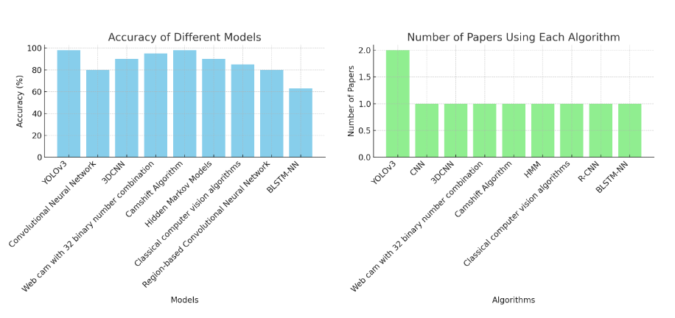

Figure 1 Graphs for accuracy vs models and model vs no. of paper

Table 1 Literature Survey

|  |  |  |  |
| --- | --- | --- | --- |
| **Name** | **Accuracy** | **Methods Used** | **Year of Publication** |
| **Machine Learning-Based Hand Sign Recognition** | **High** | 1. **TensorFlow Lite** 2. **Camera Plugin** 3. **CNN** 4. **RNN** | **2023** |
| **Hand sign**  **recognition for**  **medical field**  **Genesis** | **95%** | 1. **YOLOv3** 2. **Convolutional Neural Network Text-to-Speech Translator** 3. **3DCNN Algorithm MLP concept** 4. **Used web cam. 32 binary number combination used for recognition. YCbCr and Canny Edge modules used.** 5. **Gesture recognition system using Hidden Markov Models (HMM).** | **2022** |
| **Hand sign recognition from depth images with multi scale density features for deaf mute person** | **98.20%** | 1. **RandomForest** 2. **SVM** 3. **MLP** | **2019** |
| **An**  **Improved**  **Custom**  **convolutional neural network based handsign recognition using machine learning algorithm** | **SIGNGRAPH12:-74.99**  **SVM:- 88.89**  **3D CNN:- 92.23**  **2D CNN:- 98.39** | 1. **KNN** 2. **SVM** 3. **CNN** 4. **2D FFT** 5. **Mediapipe** 6. **ANN** 7. **PCANet** | **2024** |
| **Fine1Hand: Learning Hand Shapes for American Sign Language Recognition** | **86% (Using Both Hands)** | 1. **CNN** 2. **Kinect 3D Pose** 3. **Openpose** 4. **ASL** | **2017** |

# 4. TOOLS AND TECHNIQUES

## 4.1 Software Parts

Table 2 Software used

|  |  |
| --- | --- |
| Processor | AMD Ryzen 7 5700U with Radeon Graphics 1.80 GHz |
| Device ID | 6E92A481-2C61-412B-B5AD-8BB4BA01BF14 |
| System type | 64-bit operating system, x64-based processor |
| Pen and touch | No pen or touch input is available for this display |
| Manufacturer | HP Pvt Ltd. |
| Wundow Edition | Windows 11 Home Single Language |
| Version | 23H2 |
| PROGRAMMING LANGUAGE | PYTHON (v**3.12.3)** |
| IDE | ANACONDA (**v22.9.0)** |

## 4.2 Libraries

4.2.1 NUMPY :

Numpy is a general-purpose array-processing package. It provides a high-performance multidimensional array object and tools for working with these arrays. It is the fundamental package for scientific computing with [Python](https://www.geeksforgeeks.org/python-programming-language/). It is open-source software.

**NumPy has various features including these important ones:**

* A powerful N-dimensional array object
* Sophisticated (broadcasting) functions
* Tools for integrating C/C++ and Fortran code
* Useful linear algebra, Fourier transform, and random number capabilities

We have used numpy to use images as a numpy array to perform various preprocessing steps on them.

### 4.2.2 PANDAS:

**Pandas**is a powerful and versatile library that simplifies the tasks of data manipulation in [Python](https://www.geeksforgeeks.org/python-programming-language/). Pandas is well-suited for working with **tabular data**, such as  **spreadsheets** or **SQL tables**.

The Pandas library is an essential tool for data analysts, scientists, and engineers working with structured data in Python.

**Here is a list of things that we can do using Pandas.**

* Data set cleaning, merging, and joining.
* Easy handling of missing data (represented as NaN) in floating point as well as non-floating point data.
* Columns can be inserted and deleted from DataFrame and higher-dimensional objects.
* Powerful group by functionality for performing split-apply-combine operations on data sets.
* Data Visualization.

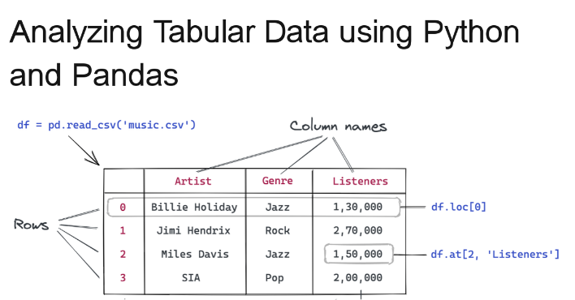

Figure 2 Pandas dataframe

### 4.2.3 OPEN CV – (CV2) :

**Opencv**is a huge open-source library for [computer vision](https://www.geeksforgeeks.org/a-quick-overview-to-computer-vision/), [machine learning](https://www.geeksforgeeks.org/ml-machine-learning/), and [image processing](https://www.geeksforgeeks.org/components-of-image-processing-system/). Now, it plays a major role in real-time operation which is very important in today’s systems. By using it, one can process images and videos to identify objects, faces, or even the handwriting of a human.

When it is integrated with various libraries, such as [NumPy,](https://www.geeksforgeeks.org/python-numpy/) [python](https://www.geeksforgeeks.org/python-programming-language/) is capable of processing the opencv array structure for analysis. To Identify an image pattern and its various features we use vector space and perform mathematical operations on these features.

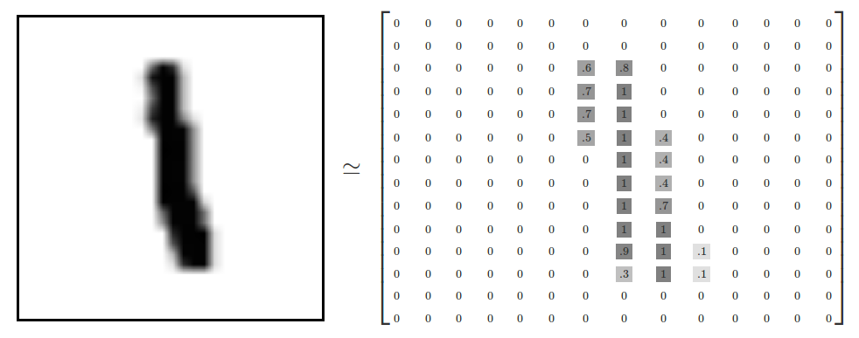

Figure 3 Image to numpy array

### 4.2.4 OS (OPERATING SYSTEM) :

The **OS module in Python** provides functions for interacting with the operating system. OS comes under Python’s standard utility modules. This module provides a portable way of using operating system-dependent functionality.The **\*os* and *os.path\*** modules include many functions to interact with the file system.

**Here we will discuss some important functions of the Python os module :**

* Handling the Current Working Directory
* Creating a Directory
* Listing out Files and Directories with Python
* Deleting Directory or Files using Python



Figure 4 OS module

### 4.2.5 PICKLE :

Python [pickle module](https://www.geeksforgeeks.org/pickle-python-object-serialization/) is used for serializing and de-serializing a Python object structure. Any object in Python can be pickled so that it can be saved on disk. What Pickle does is it “serializes” the object first before writing it to a file. Pickling is a way to convert a Python object (list, dictionary, etc.) into a character stream. The idea is that this character stream contains all the information necessary to reconstruct the object in another [Python](https://www.geeksforgeeks.org/python-programming-language/) script. It provides a facility to convert any Python object to a byte stream. This Byte stream contains all essential information about the object so that it can be reconstructed, or “unpickled” and get back into its original form in any Python.

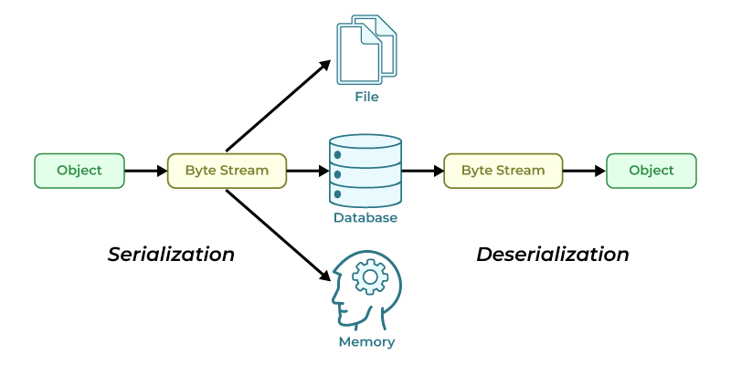

Figure 5 pickle method in python

### 4.2.6 MEDIAPIPE :

Google developed Mediapipe as an open-source framework for building and deploying machine-learning pipelines. These pipelines can process multimedia data like text, video, and audio in real time. You can combine its pre-built components, also known as "Calculators,” to create computer vision pipelines. It has many predefine landmarks for hand and face which used for tasks such as face recognition.

Basically it provide (x,y,z) component of each landmark it detect in the frame and based on these co-ordinates we classified our test images. It is very easy to use as it doesn’t require much preprocessing in the image, It takes BGR image as input and detect hands in it by its pretend model.



Figure 6 Mediapipe

**Working of mediapipe:**

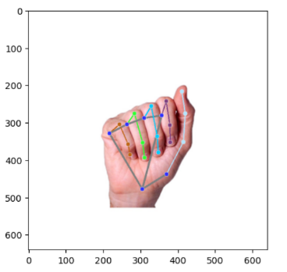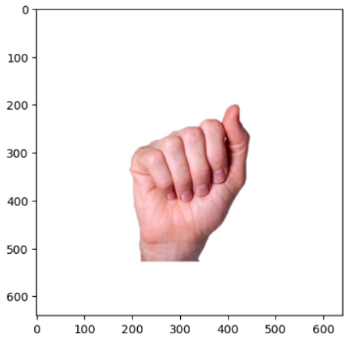

**STEPS :**

* 1. Here total 21 points/landmarks are there onEach hand. Every point has its coordinates so We extract this coordinates (x,y) from it.
  2. Now after extraction we store all coordinates in a list and label it with the symbol name. These coordinates will works as the features for our models, mediapipe differentiate them based on the angles between them.
  3. After training the algorithm we give new image for testing and then mediapipe extract its point and these points were given to our model.
  4. As our model get trained on these features, it will predict the class according its algorithm.
  5. Now finally we will get our output as a class label.

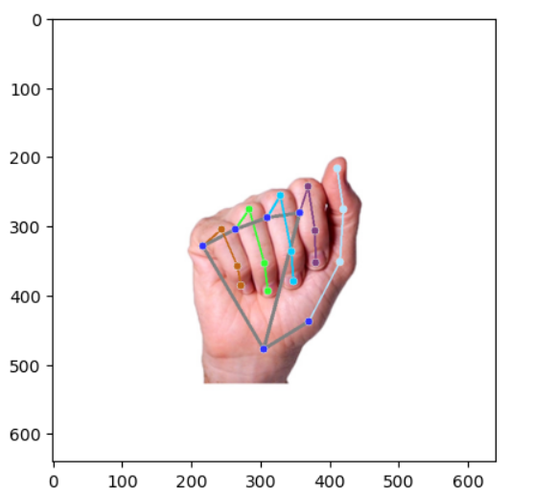

Output :

Figure 7 output of mediapipe

### 4.2.7 SCIKIT LEARN :

Scikit-learn is an open-source[Python](https://www.geeksforgeeks.org/python-programming-language/) library that implements a range of machine learning, pre-processing, cross-validation, and visualization algorithms using a unified interface. It is an open-source machine-learning library that provides a plethora of tools for various [machine-learning](https://www.geeksforgeeks.org/machine-learning/) tasks such as[Classification](https://www.geeksforgeeks.org/basic-concept-classification-data-mining/), [Regression](https://www.geeksforgeeks.org/regression-classification-supervised-machine-learning/), [Clustering](https://www.geeksforgeeks.org/clustering-in-machine-learning/), and many more.

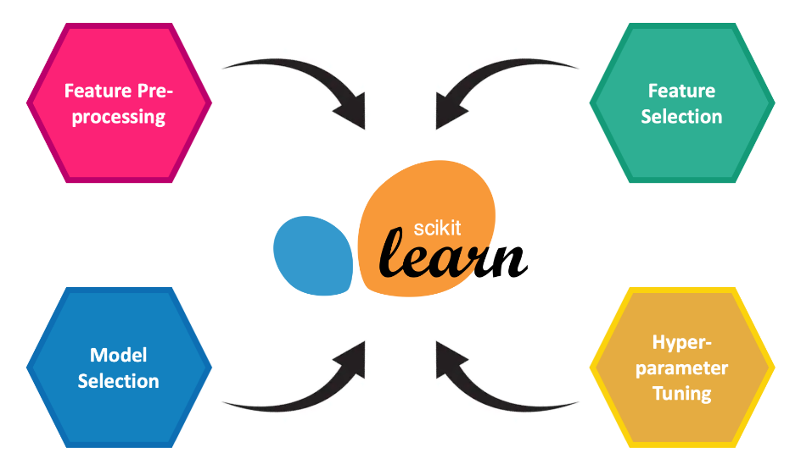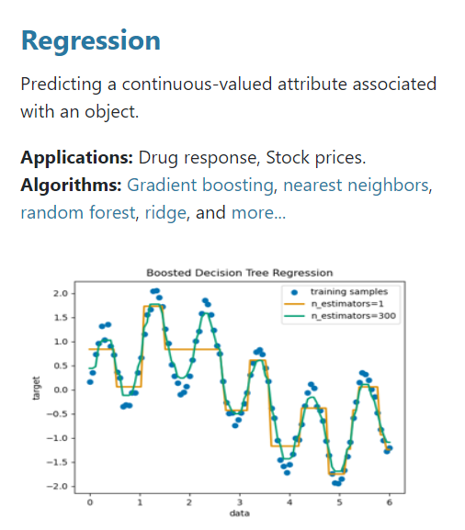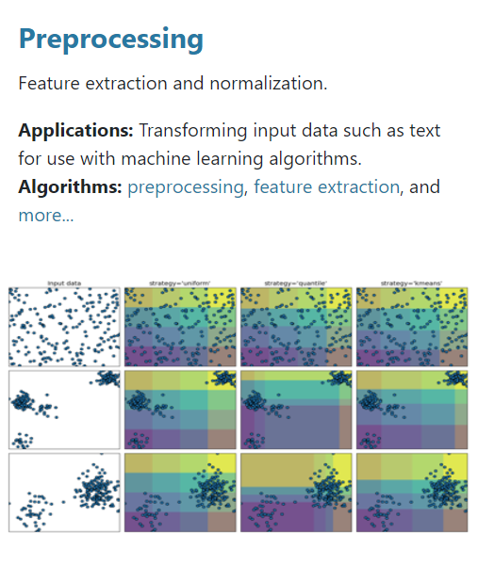

Figure 8 Regression

Figure 9 preprocessing

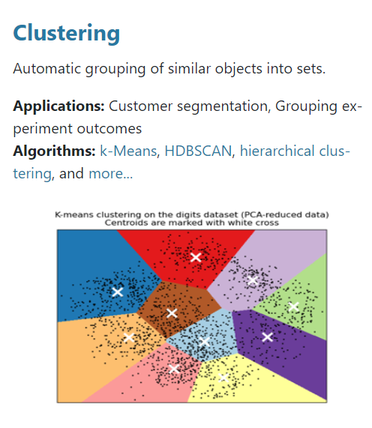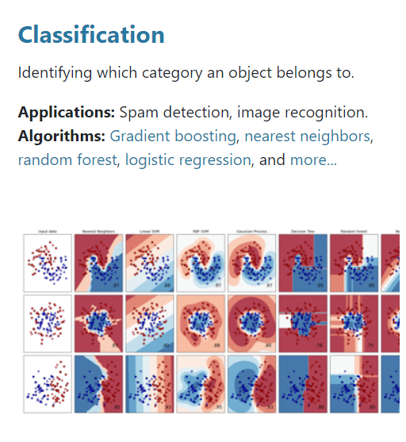

Figure 10 clustering

Figure 11 classification

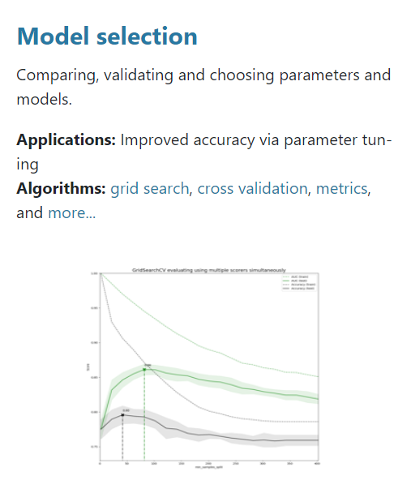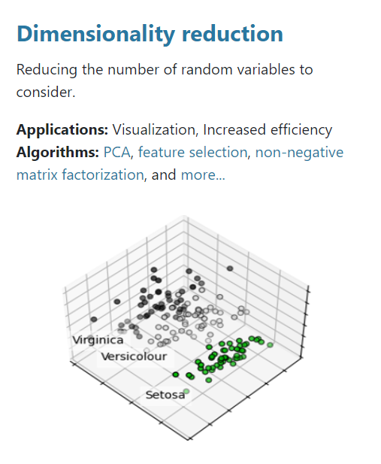

Figure 12 model selection

Figure 13 dimentionality reduction

**Features of sklearn :**

* Simple and efficient tools for predictive data analysis
* Accessible to everybody, and reusable in various contexts
* Built on NumPy, SciPy, and matplotlib
* Open source, commercially usable - BSD license

# 5. BACKGROUND PRINCIPLES

## 5.1 Data Preprocessing

Data preprocessing is the process of transforming raw data into an understandable

format. It is also an important step in data mining as we cannot work with raw data. The quality of the data should be checked before applying machine learning or data mining algorithms.

**Why is Data preprocessing important?**

Preprocessing of data is mainly to check the data quality. The quality can be checked by the following

* **Accuracy**: To check whether the data entered is correct or not.
* **Completeness**: To check whether the data is available or not recorded.
* **Consistency:** To check whether the same data is kept in all the places that do or do not match.
* **Timeliness**: The data should be updated correctly.
* **Believability**: The data should be trustable.
* **Interpretability**: The understandability of the data.

**Major Tasks in Data Preprocessing:**

1. *Data cleaning*
2. *Data integration*
3. *Data reduction*
4. *Data transformation*

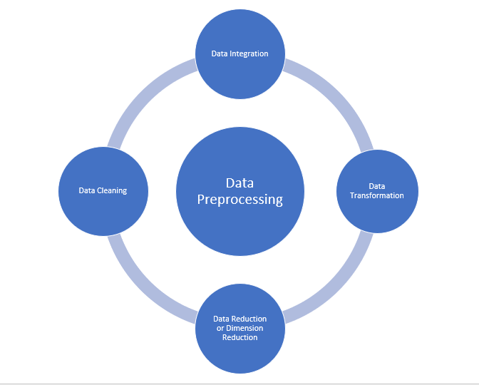

Figure 14 Data preprocessing

### 5.1.1 Data cleaning:

Data cleaning is the process to remove incorrect data, incomplete data and inaccurate data from the datasets, and it also replaces the missing values. There are some techniques in data cleaning

**Handling missing values:**

* Standard values like “Not Available” or “NA” can be used to replace the missing values.
* Missing values can also be filled manually but it is not recommended when that dataset is big.
* The attribute’s mean value can be used to replace the missing value when the data is normally distributed wherein in the case of non-normal distribution median value of the attribute can be used.
* While using regression or decision tree algorithms the missing value can be replaced by the most probable value.

**Noisy:**

          Noisy generally means random error or containing unnecessary data points. Here are some of the methods to handle noisy data.

* **Binning**: This method is to smooth or handle noisy data. First, the data is sorted then and then the sorted values are separated and stored in the form of bins. There are three methods for smoothing data in the bin. **Smoothing by bin mean method**: In this method, the values in the bin are replaced by the mean value of the bin; **Smoothing by bin median**: In this method, the values in the bin are replaced by the median value; **Smoothing by bin boundary**: In this method, the using minimum and maximum values of the bin values are taken and the values are replaced by the closest boundary value.
* **Regression**: This is used to smooth the data and will help to handle data when unnecessary data is present. For the analysis, purpose regression helps to decide the variable which is suitable for our analysis.
* **Clustering**: This is used for finding the outliers and also in grouping the data. Clustering is generally used in unsupervised learning.

### 5.1.2 Data integration:

          The process of combining multiple sources into a single dataset. The Data integration process is one of the main components in data management. There are some problems to be considered during data integration.

* **Schema integration**: Integrates metadata(a set of data that describes other data) from different sources.
* **Entity identification problem:** Identifying entities from multiple databases. For example, the system or the use should know student _id of one database and student_name of another database belongs to the same entity.
* **Detecting and resolving data value concepts**: The data taken from different databases while merging  may differ. Like the attribute values from one database may differ from another database. For example, the date format may differ like “MM/DD/YYYY” or “DD/MM/YYYY”.

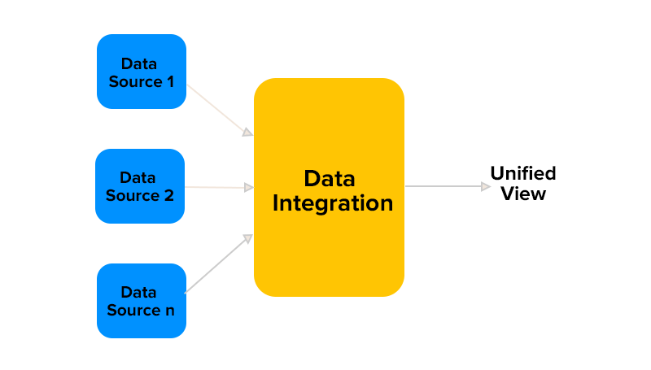

Figure 15 data integration

### 5.1.3 Data Transformation:

       The change made in the format or the structure of the data is called data transformation. This step can be simple or complex based on the requirements. There are some methods in data transformation.

* **Smoothing**: With the help of algorithms, we can remove noise from the dataset and helps in knowing the important features of the dataset. By smoothing we can find even a simple change that helps in prediction.
* **Aggregation**: In this method, the data is stored and presented in the form of a summary. The data set which is from multiple sources is integrated into with data analysis description. This is an important step since the accuracy of the data depends on the quantity and quality of the data. When the quality and the quantity of the data are good the results are more relevant.
* **Discretization**: The continuous data here is split into intervals. Discretization reduces the data size. For example, rather than specifying the class time, we can set an interval like (3 pm-5 pm, 6 pm-8 pm).
* **Normalization:** It is the method of scaling the data so that it can be represented in a smaller range. Example ranging from -1.0 to 1.0.

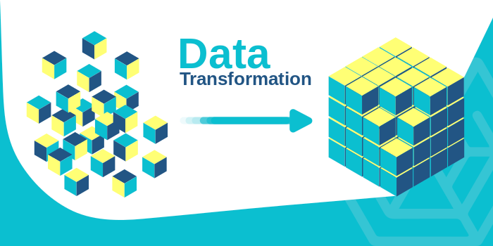

Figure 16 data transformation

### 5.1.4 Data reduction:

         This process helps in the reduction of the volume of the data which makes the analysis easier yet produces the same or almost the same result. This reduction also helps to reduce storage space. There are some of the techniques in data reduction are Dimensionality reduction, Numerosity reduction, Data compression.

* **Dimensionality reduction:**This process is necessary for real-world applications as the data size is big. In this process, the reduction of random variables or attributes is done so that the dimensionality of the data set can be reduced. Combining and merging the attributes of the data without losing its original characteristics. This also helps in the reduction of storage space and computation time is reduced. When the data is highly dimensional the problem called “Curse of Dimensionality” occurs.
* **Numerosity Reduction:**In this method, the representation of the data is made smaller by reducing the volume. There will not be any loss of data in this reduction.
* **Data compression:**The compressed form of data is called data compression. This compression can be lossless or lossy. When there is no loss of information during compression it is called lossless compression. Whereas lossy compression reduces information but it removes only the unnecessary information.

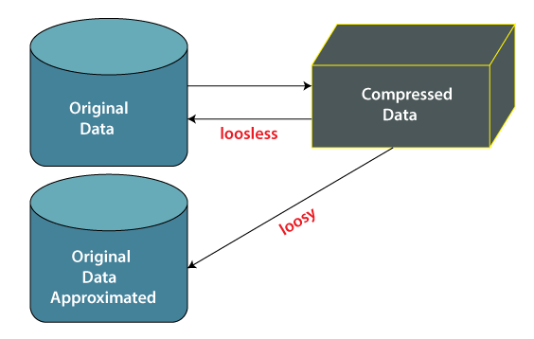

Figure 17 data reduction

### 5.1.5 Feature Selection and Feature Extraction:

* Feature selection is a way of selecting the subset of the most relevant features from the original features set by removing the redundant, irrelevant, or noisy features.
* A feature is an attribute that has an impact on a problem or is useful for the problem, and choosing the important features for the model is known as feature selection. Each machine learning process depends on feature engineering, which mainly contains two processes; which are Feature Selection and Feature Extraction.
* Although feature selection and extraction processes may have the same objective, both are completely different from each other. The main difference between them is that feature selection is about selecting the subset of the original feature set, whereas feature extraction creates new features. Feature selection is a way of reducing the input variable for the model by using only relevant data in order to reduce overfitting in the model.

**Below are some benefits of using feature selection in machine learning:**

* It helps in avoiding the curse of dimensionality.
* It helps in the simplification of the model so that it can be easily interpreted by the researchers.
* It reduces the training time.
* It reduces overfitting hence enhance the generalization

**Feature Selection Techniques**

There are mainly two types of Feature Selection techniques, which are:

* **Supervised Feature Selection technique** Supervised Feature selection techniques consider the target variable and can be used for the labelled dataset.
* **Unsupervised Feature Selection technique** Unsupervised Feature selection techniques ignore the target variable and can be used for the unlabelled dataset.

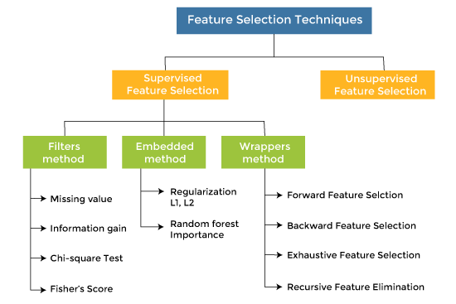

Figure 18 Feature selection

## 5.2 Machine Learning Techniques

Machine Learning is the field of study that gives computers the capability to learn without being explicitly programmed. ML is one of the most exciting technologies that one would have ever come across. As it is evident from the name, it gives the computer that makes it more similar to humans: The ability to learn.

**Types of Machine Learning :**

There are several types of machine learning, each with special characteristics and applications. Some of the main types of machine learning algorithms are as follows:

1. Supervised Machine Learning
2. Unsupervised Machine Learning
3. Semi-Supervised Machine Learning
4. Reinforcement Learning

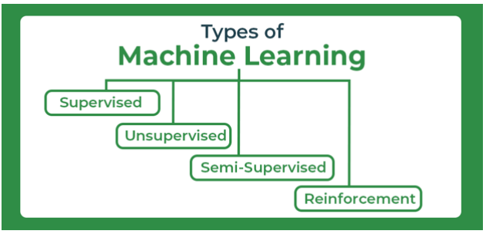

Figure 19 Types of machine learning

### 5.2.1 Supervised Machine Learning :

Supervised Machine Learning  is defined as when a model gets trained on a **“Labelled Dataset”**. Labelled datasets have both input and output parameters. In **Supervised Learning** algorithms learn to map points between inputs and correct outputs. It has both training and validation datasets labelled.

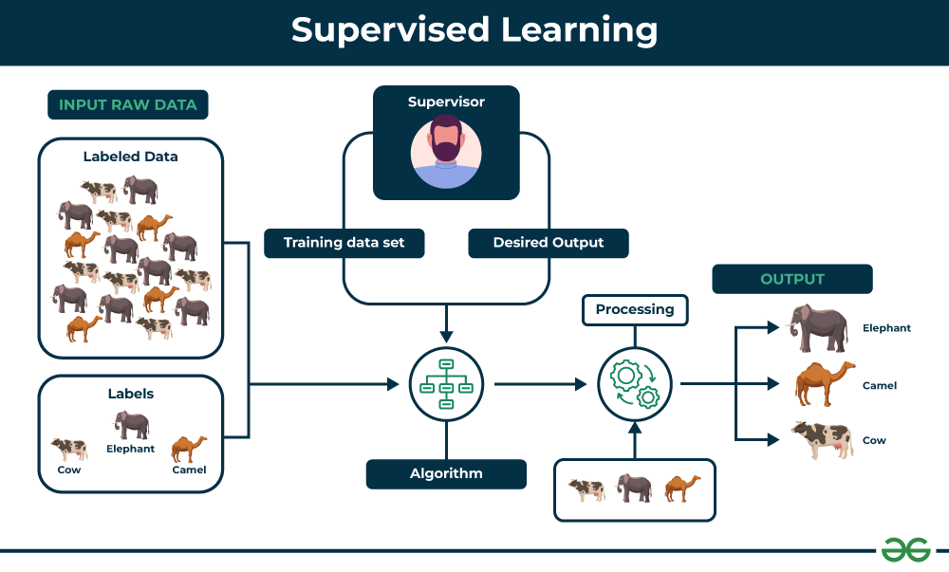

Figure 20 supervised learning

There are two main categories of supervised learning that are mentioned below:

* [**Classification**](https://www.geeksforgeeks.org/getting-started-with-classification/)
* [**Regression**](https://www.geeksforgeeks.org/types-of-regression-techniques/)

[**Classification**](https://www.geeksforgeeks.org/getting-started-with-classification/)deals with predicting **categorical** target variables, which represent discrete classes or labels. For instance, classifying emails as spam or not spam, true/false, male/female, yes/no, first/second/third etc.

[**Regression**](https://www.geeksforgeeks.org/regression-classification-supervised-machine-learning/), on the other hand, deals with predicting **continuous** target variables, which represent numerical values. For example, predicting the price of a house based on its size, location, and amenities, or forecasting the sales of a product etc.

### 5.2.2 Unsupervised Machine Learning

[Unsupervised Learning](https://www.geeksforgeeks.org/unsupervised-machine-learning-the-future-of-cybersecurity/) Unsupervised learning is a type of machine learning technique in which an algorithm discovers patterns and relationships using unlabeled data. Unlike supervised learning, unsupervised learning doesn’t involve providing the algorithm with labeled target outputs. The primary goal of Unsupervised learning is often to discover hidden patterns, similarities, or clusters within the data, which can then be used for various purposes, such as data exploration, visualization, dimensionality reduction, and more.

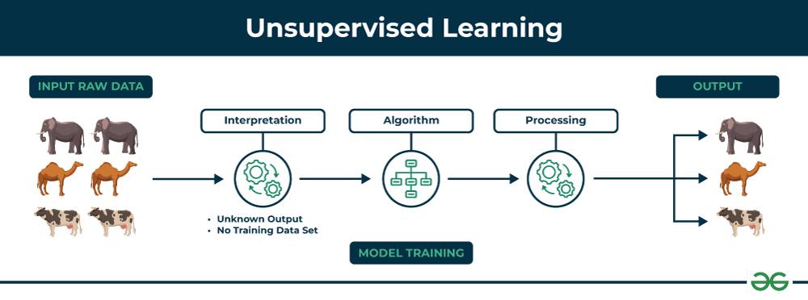

Figure 21 Unsupervised machine learning

There are two main categories of unsupervised learning that are mentioned below:

* [Clustering](https://www.geeksforgeeks.org/clustering-in-machine-learning/)
* [Association](https://www.geeksforgeeks.org/association-rule/)

[**Clustering**](https://www.geeksforgeeks.org/clustering-in-machine-learning/) is the process of grouping data points into clusters based on their similarity. This technique is useful for identifying patterns and relationships in data without the need for labeled examples.

[**Association** rule learn](https://www.geeksforgeeks.org/association-rule/)ing is a technique for discovering relationships between items in a dataset. It identifies rules that indicate the presence of one item implies the presence of another item with a specific probability.

### 5.2.3. Semi-Supervised Learning

* [Semi-Supervised learning](https://www.geeksforgeeks.org/ml-semi-supervised-learning/)is a machine learning algorithm that works between the [supervised and unsupervised](https://www.geeksforgeeks.org/supervised-unsupervised-learning/) learning so it uses both **labelled and unlabelled** data. It’s particularly useful when obtaining labeled data is costly, time-consuming, or resource-intensive.
* This approach is useful when the dataset is expensive and time-consuming. Semi-supervised learning is chosen when labeled data requires skills and relevant resources in order to train or learn from it .

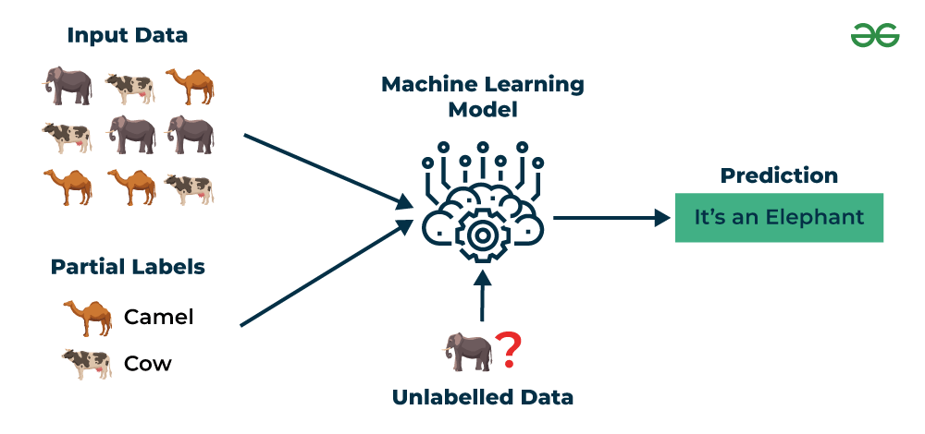

Figure 22 semi supervised

### 5.2.4 Reinforcement Machine Learning

* [Reinforcement machine learning](https://www.geeksforgeeks.org/what-is-reinforcement-learning/)algorithm is a learning method that interacts with the environment by producing actions and discovering errors. **Trial, error, and delay** are the most relevant characteristics of reinforcement learning. In this technique, the model keeps on increasing its performance using Reward Feedback to learn the behavior or pattern.
* These algorithms are specific to a particular problem e.g. Google Self Driving car, AlphaGo where a bot competes with humans and even itself to get better and better performers in Go Game. Each time we feed in data, they learn and add the data to their knowledge which is training data. So, the more it learns the better it gets trained and hence experienced.

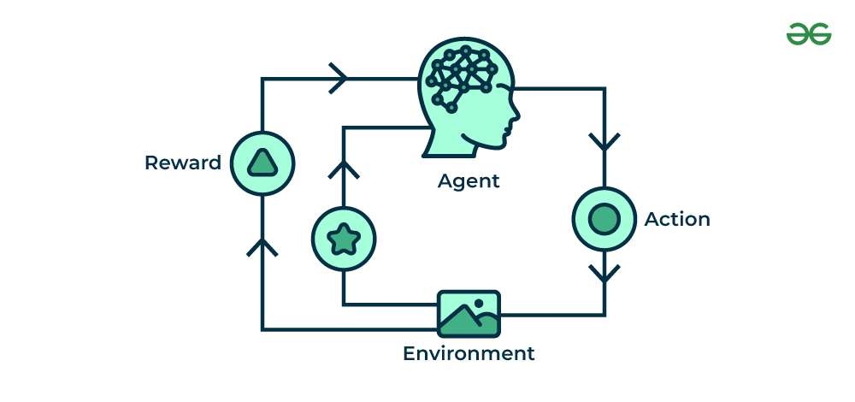

Figure 23 reinforcement learning

## 5.3 Classification Algorithms

* Classification is a process of categorizing data or objects into predefined classes or categories based on their features or attributes.
* [Machine Learning](https://www.geeksforgeeks.org/machine-learning/) classification is a type of [supervised learning](https://www.geeksforgeeks.org/machine-learning/#su) technique where an algorithm is trained on a labeled dataset to predict the class or category of new, unseen data.
* The main objective of classification machine learning is to build a model that can accurately assign a label or category to a new observation based on its features.
* For example, a classification model might be trained on a dataset of images labeled as either dogs or cats and then used to predict the class of new, unseen images of dogs or cats based on their features such as color, texture, and shape.

**Classification Types**

There are two main classification types in machine learning:

* **Binary Classification :**

In binary classification, the goal is to classify the input into one of two classes or categories. Example – On the basis of the given health conditions of a person, we have to determine whether the person has a certain disease or not.

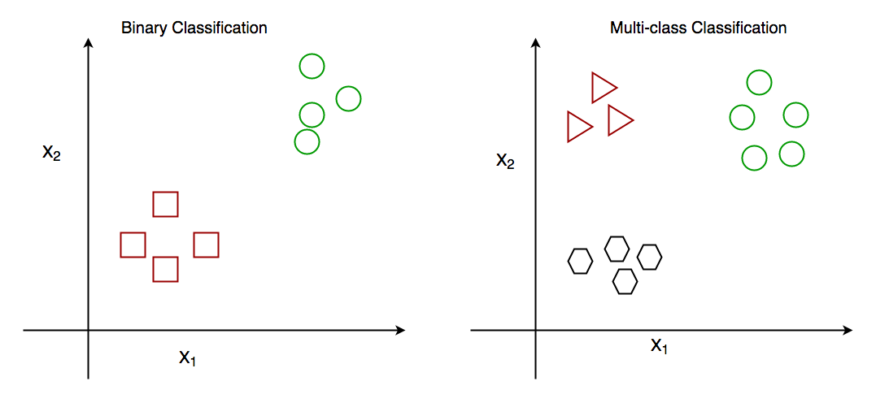

* **Multiclass Classification :**

In multi-class classification, the goal is to classify the input into one of several classes or categories. For Example – On the basis of data about different species of flowers, we have to determine which specie our observation belongs to.

### 5.3.1 KNN [K-NEAREST NEIGHBORS] :

* + The K-Nearest Neighbors (KNN) algorithm is a supervised machine learning method employed to tackle classification and regression problems.
  + Thе K-Nearest Neighbors (KNN) algorithm operates on the principle of similarity, where it predicts the label or value of a new data point by considering the labels or values of its K nearest neighbors in the training dataset.

**STEPS :**

* 1. Choose the value of K.
  2. Measure the distance between test point and training datapoints using any distance metrics.
  3. Now sort the data points according to the distance and choose First K datapoint’s label/target and perform aggregartion.
  4. Aggregation :

For classification :- Take the mode of target class of first k samples

For regression : - Take the mean of target calss values.

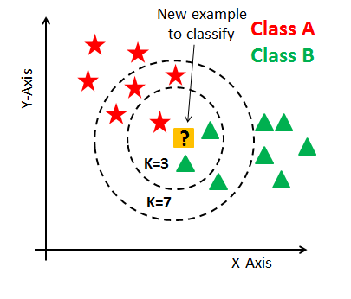

Figure 24 KNN

### 5.3.2 DECISION TREE :

* A decision tree is a flow chart like tree structure where each internal mode denotes the feature, branches denote the rules and the leaf node denotes the result of the algorithm. It is used for classification as well as for regression.
* Decision tree uses the tree representation to solve the problem in which each leaf node corresponds to a class label and attributes are represented on the internal node of the tree. We can represent any boolean function on discrete attributes using the decision tree.

**STEPS :**

1. Begin the tree with the root node, say S which contains whole dataset.
2. Find the best attribute in the dataset using Attribute selection measure Information gain / entropy / gini index / chisquare.
3. Divide the S into subsets say s1,s2,….sn. That contains possible values for the best attributes
4. Generate the decision tree node, which contains the best attribute
5. Recursively make new decision trees using the subsets of the dataset created in step 3

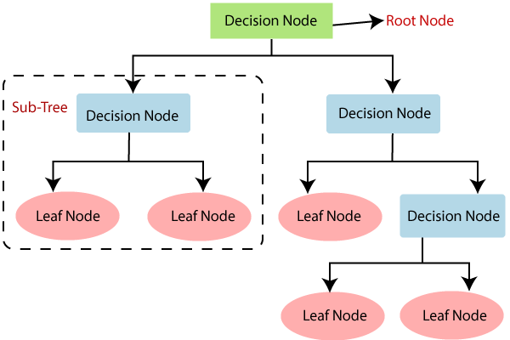

Figure 25 decision tree

The major challenge is the identification of the attribute for the root node at each level. This process is known as attribute selection. We have two popular attribute selection measures:

1. **Information Gain**
2. **Gini Index**
3. **Entropy**
4. **Chi-square**

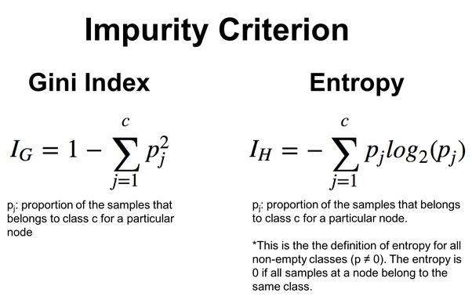

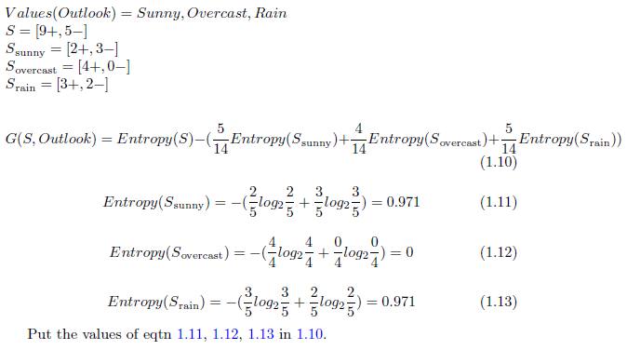

Figure 26 Example for entropy

Figure 27 Impurity Criterion

### 5.3.3 SVM [SUPPORT VECTOR MACHINE] :

* Support Vector Machine (SVM) is a supervised machine learning algorithm used for both classification and regression. It uses hyperplane to separate two classes, the class above the hyperplane is positive class and the class below the hyperplane is said to be negative class.
* Our main objective in svm is to maximize the margin of hyperplane and then that hyperplane is said to be best/optimal hyperplane.

**There are two types of SVM :**

1. Linear SVM:

Linear SVMs use a linear decision boundary to separate the data points of different classes. This means that a single straight line (in 2D) or a hyperplane (in higher dimensions) can entirely divide the data points into their respective classes.

1. Non Linear SVM:

Non-Linear SVM can be used to classify data when it cannot be separated into two classes by a straight line (in the case of 2D). By using kernel functions, nonlinear SVMs can handle nonlinearly separable data.

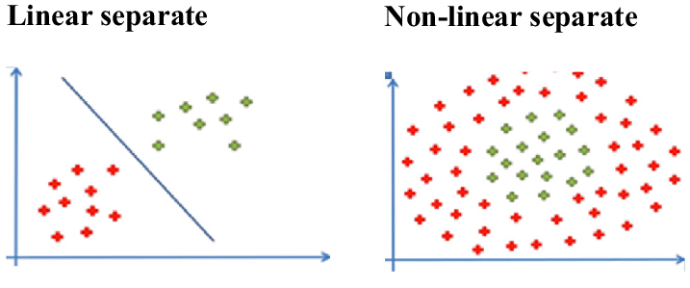

Figure 28 Linear and non-Linear SVM

* Our main motive is to maximize this function “ 2 / ||W|| ” with respect to the constraint that ***y(w.x+b)>1*** for every datapoint ***X*** and feature vector ***W.***



Figure 29 svm optimal function

* **KERNEL TRICK IN SVM :**

The SVM kernel is a function that takes low-dimensional input space and transforms it into higher-dimensional space, ie it converts nonseparable problems to separable problems. It is mostly useful in non-linear separation problems.

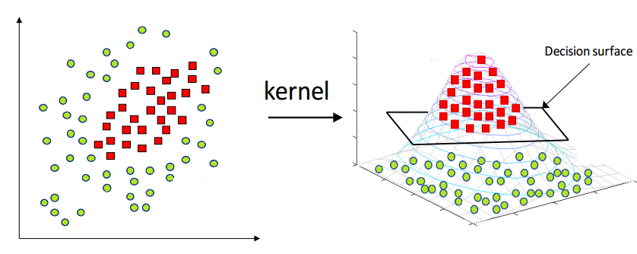

Figure 30 SVM kernel example

**Some of the useful kernels of svm:**

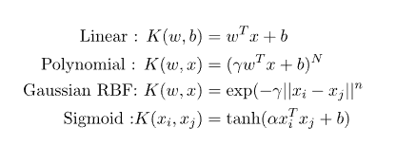 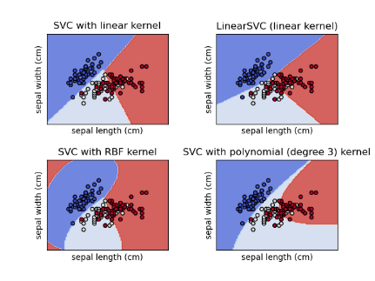 **Important Parameters in Kernelized SVC**

* **The Kernel** : The kernel, is selected based on the type of data and also the type of transformation. By default, the kernel is Radial Basis Function Kernel (RBF).
* **Gamma** : This parameter decides how far the influence of a single training example reaches during transformation, which in turn affects how tightly the decision boundaries end up surrounding points in the input space. If there is a small value of gamma, points farther apart are considered similar. So more points are grouped together and have smoother decision boundaries (may be less accurate). Larger values of gamma cause points to be closer together (may cause overfitting).
* **The ‘C’ parameter** : This parameter controls the amount of regularization applied on the data. Large values of C means low regularization which in turn causes the training data to fit very well (may cause overfitting). Lower values of C mean higher regularization which causes the model to be more tolerant of errors (may lead to lower accuracy)

### 5.3.4 RANDOM FOREST :

* Random Forest algorithm is a powerful tree learning technique in [Machine Learning](https://www.geeksforgeeks.org/ml-machine-learning/). It works by creating a number of [Decision Trees](https://www.geeksforgeeks.org/decision-tree/) during the training phase.
* Each tree is constructed using a random subset of the data set to measure a random subset of features in each partition. This randomness introduces variability among individual trees, reducing the risk of [overfitting](https://www.geeksforgeeks.org/underfitting-and-overfitting-in-machine-learning/) and improving overall prediction performance.
* In prediction, the algorithm aggregates the results of all trees, either by voting (for classification tasks) or by averaging (for regression tasks) This collaborative decision-making process, supported by multiple trees with their insights, provides an example stable and precise results.
* Random forests are widely used for classification and regression functions, which are known for their ability to handle complex data, reduce overfitting, and provide reliable forecasts in different environments.

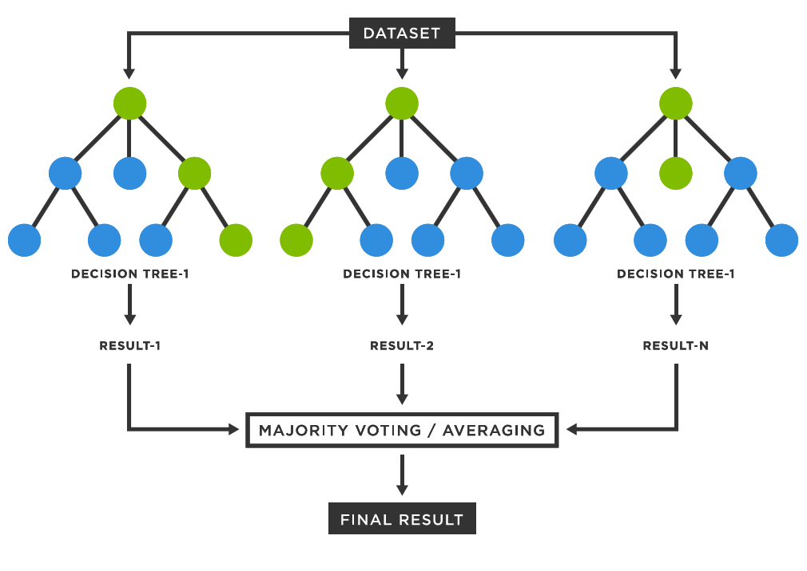

Figure 31 random forest

* Random Forest employs a technique called bootstrap aggregating or bagging, where each decision tree is trained on a random subset of the training data with replacement.
* During prediction, Random Forest combines the predictions from individual decision trees through a voting mechanism (for classification) or averaging (for regression).

It is the collection of decision tree in which the decision trees get trained through boostraping of dataset.

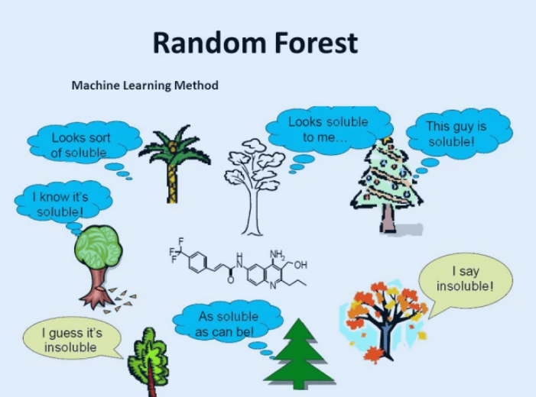

Figure 32 random forest

**Why use Random Forest?**

* It takes less training time as compared to other algorithms.
* It predicts output with high accuracy, even for the large dataset it runs efficiently.
* It can also maintain accuracy when a large proportion of data is missing.

**How does the algorithm work?**

It works in four steps:

1. Select random samples from a given dataset.
2. Construct a decision tree for each sample and get a prediction result from each decision tree.
3. Perform a vote for each predicted result.

Select the prediction result with the most votes as the final prediction

### 5.3.5 NAÏVE BAYES :

* Naïve Bayes algorithm is used for classification problems. It is highly used in text classification. In text classification tasks, data contains high dimension (as each word represent one feature in the data).
* It is used in spam filtering, sentiment detection, rating classification etc. The advantage of using naïve Bayes is its speed. It is fast and making prediction is easy with high dimension of data.
* This model predicts the probability of an instance belongs to a class with a given set of feature value. It is a probabilistic classifier. It is because it assumes that one feature in the model is independent of existence of another feature.
* In other words, each feature contributes to the predictions with no relation between each other. In real world, this condition satisfies rarely. It uses Bayes theorem in the algorithm for training and prediction

**Bayes’ Theorem**

* Bayes’ Theorem finds the probability of an event occurring given the probability of another event that has already occurred. Bayes’ theorem is stated mathematically as the following equation:

**𝑃(𝐴∣𝐵)=𝑃(𝐵∣𝐴)𝑃(𝐴)𝑃(𝐵)*P*(*A*∣*B*)=*P*(*B*)*P*(*B*∣*A*)*P*(*A*)​**

where A and B are events and P(B) ≠ 0

* Now, with regards to our dataset, we can apply Bayes’ theorem in following way:

𝑃(𝑦∣𝑋)=𝑃(𝑋∣𝑦)𝑃(𝑦)𝑃(𝑋)*P*(*y*∣*X*)=*P*(*X*)*P*(*X*∣*y*)*P*(*y*)​

where, y is class variable and X is a dependent feature vector (of size *n*)

𝑋=(𝑥1,𝑥2,𝑥3,…..,𝑥𝑛)*X*=(*x*1​,*x*2​,*x*3​,…..,*xn*​)

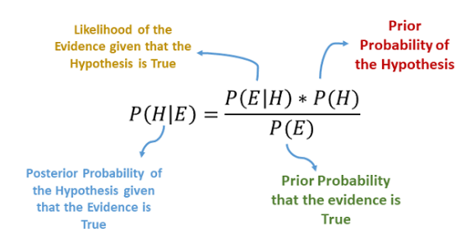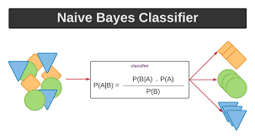

**Types of Naive Bayes Model**

There are three types of Naive Bayes Model:

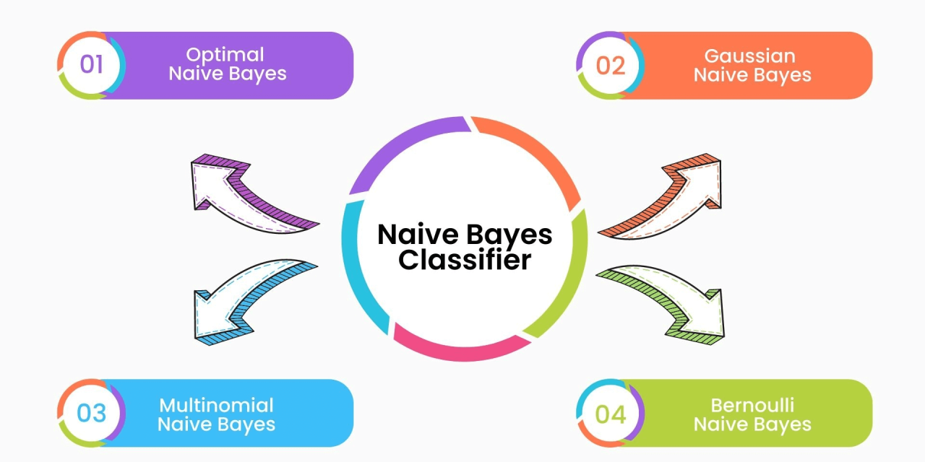

Figure 33 naive bayes type

5.3.6 ENSEMBLE LEARNING :

* Ensemble learning is a machine learning technique that enhances accuracy and resilience in forecasting by merging predictions from multiple models. It aims to mitigate errors or biases that may exist in individual models by leveraging the collective intelligence of the ensemble.

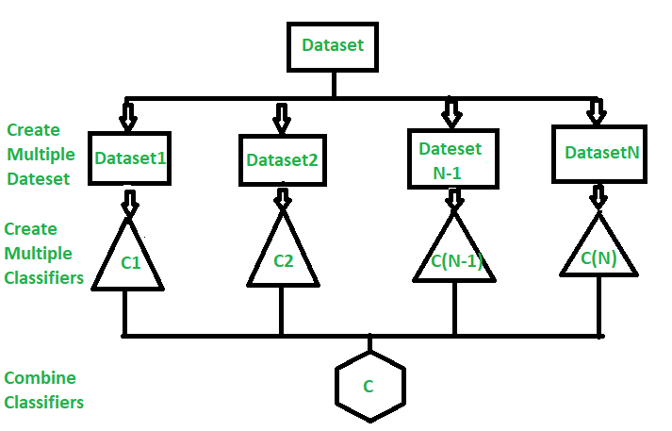

Figure 34 Ensemble learning

**Ensemble algorithms or methods can be divided into two groups:**

* **Sequential ensemble methods**  where the base learners are generated sequentially (e.g. AdaBoost). The basic motivation of sequential methods is to exploit the dependence between the base learners. The overall performance can be boosted by weighing previously mislabeled examples with higher weight.
* **Parallel ensemble methods** where the base learners are generated in parallel (e.g. Random Forest).The basic motivation of parallel methods is to exploit independence between the base learners since the error can be reduced dramatically by averaging.

### 5.3.7 BAGGING :

Bagging is an ensemble learning technique, it is the process of combinning result of multiple models (with same algorithm) to get a generalized result.

* **BOOTSTARPPING :**

It is a sampling technique in which we createSubsets of observations from the original Dataset, with replacement

* **AGGREGATION :**

Classification : Mode of all the predicted classes.

Regression : Average of all the predicted values.

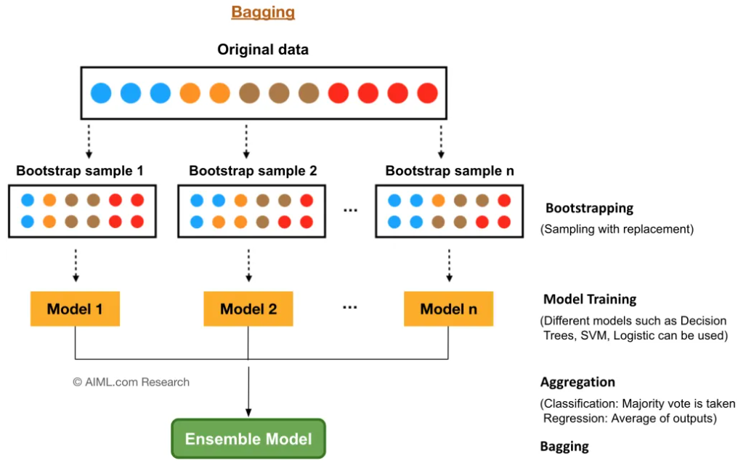

Figure 35 bagging

### 5.3.8 BOOSTING :

* Boosting is an ensemble modeling technique that attempts to build a strong classifier from the number of weak classifiers. It is done by building a model by using weak models in series.
* Firstly, a model is built from the training data. Then the second model is built which tries to correct the errors present in the first model.
* This procedure is continued and models are added until either the complete training data set is predicted correctly or the maximum number of models are added.

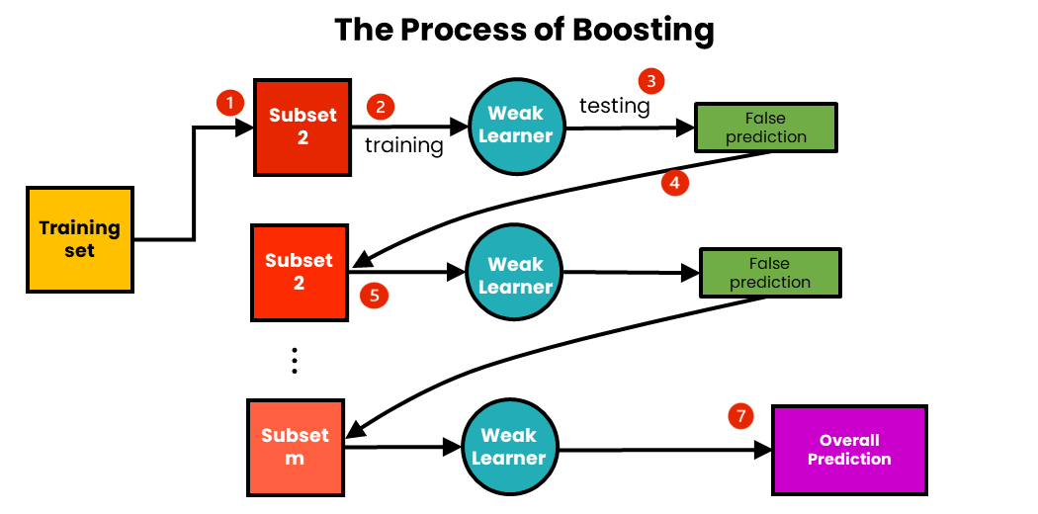

Figure 36 Boosting

***How Boosting works* :**

* Here D1,D2,D3 are decision stumps(decision tree model with Depth=1). D4 is the final model trained from misclassified as well as Classified points of weak learners.
* **Types of Boosting Algorithms** :

1. **Adaboost**
2. **Gradient Boosting**
3. **XGBoost**

* It is a parallel ensemble method in which several weak learner learn from the mistakes / misclassifications / errors of previous weak learner. The next weak learner try to avoid the previous mistakes and in this way it works to get a optimal model.

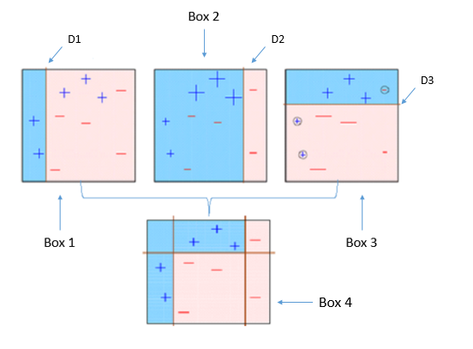

Figure 37 boosting work

### 5.3.9 ADABOOST :

* AdaBoost is a boosting algorithm that also works on the principle of the stagewise addition method where multiple weak learners are used for getting strong learners.

* The value of the alpha parameter, in this case, will be indirectly proportional to the error of the weak learners**.**

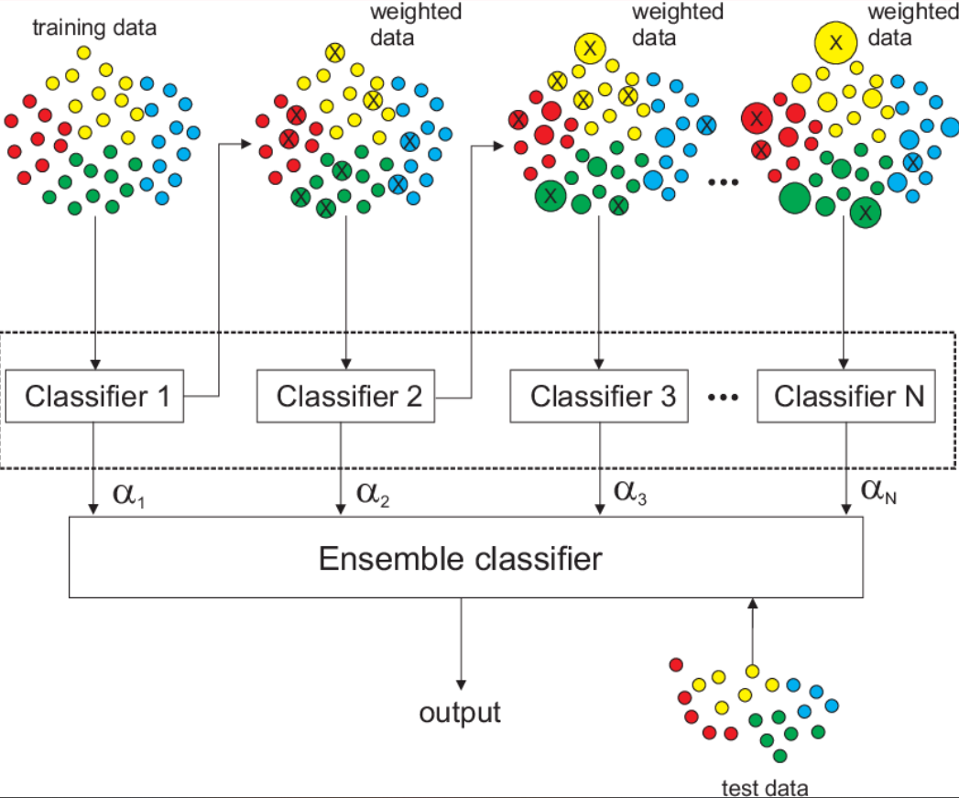

Figure 38 adaboost

**How Adaboost works :**

1. Assign initial weights (1/n) to each datapoint.
2. Train a weak learner on the dataset and calculate the error and Alpha

**ERROR =** sum of weights of misclassified points

1. Now assign the new weights to all points:

4. Normalize the weights in such a way that $\sum{wts=1}$**.**

1. Now make range according to weights and perform upsampling using new weights.
2. Repeat from step 2 again for new weak learner.

* In this manner in the last we have n models and for any unknown pt, we ask each model and we give importance to answer of each model according to their value of $α$**.**

**H(x)= $α_{1}$ h(x1) + $α_{2}$ h(x2) + $α_{3}$ h(x3) . . . . . . + $α_{n}$ h(xn)**

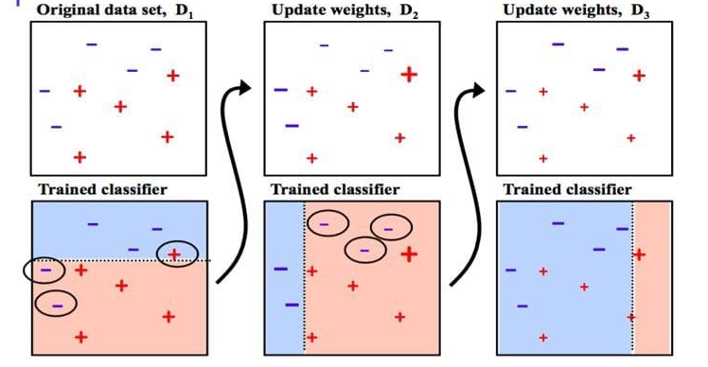

Figure 39 adaboost

## **5.4 Hyper parameter tuning**

* Hyperparameter tuning is the process of selecting the optimal values for a machine learning model’s hyperparameters.
* Hyperparameters are settings that control the learning process of the model, such as the learning rate, the number of neurons in a neural network, or the kernel size in a support vector machine.
* The goal of hyperparameter tuning is to find the values that lead to the best performance on a given task.

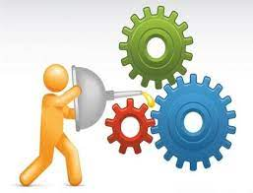

Paramters of algorithm

Tuning of paramters to obtain best result

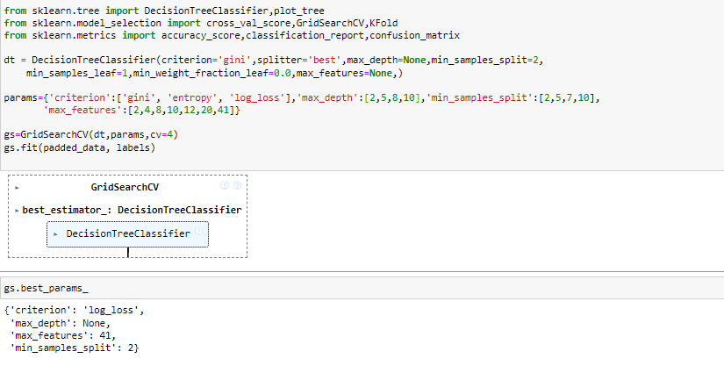

Figure 40 hyperparameter tuining

# 6. METHODOLOGY

## 

Figure 41 Flowchart for methodology

## **6.1 Preprocesing**

* When preparing data for MediaPipe, especially for tasks involving image or video processing, it's essential to preprocess your data to ensure compatibility and optimal performance. Here are the key preprocessing steps:

### 6.1.1 Resize:

* Resizing images or frames to a consistent dimension ensures uniformity in input size for MediaPipe models or components.
* This step is crucial for optimizing computational efficiency and maintaining aspect ratios across different devices or platforms.

### 6.1.2 Color Conversion:

* Converting the color space of images, such as from RGB to BGR or vice versa, aligns the data format with MediaPipe's internal processing requirements.
* This ensures accurate interpretation of color information and facilitates seamless integration with various image processing pipelines within MediaPipe.

### 6.1.3 Segmentation:

* Segmenting images involves isolating specific regions or objects within an image, which can enhance the precision of subsequent tasks like object detection or background removal in MediaPipe applications.
* This preprocessing step helps focus computational resources on relevant areas of interest, improving overall performance and accuracy.

### 6.1.4 Normalization:

* Normalizing pixel values adjusts the numerical range of image data to a standardized scale, typically [0, 1] or [-1, 1]. This standardization enhances model convergence during training and inference within MediaPipe, promoting consistent and reliable output across different datasets and input variations.
* Normalization also reduce the issues related to data distribution, ensuring robust performance of machine learning models and algorithms integrated into MediaPipe pipelines.

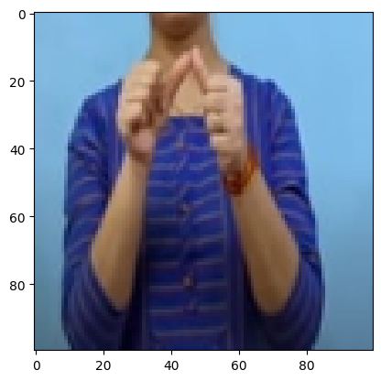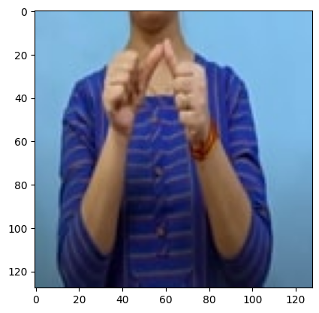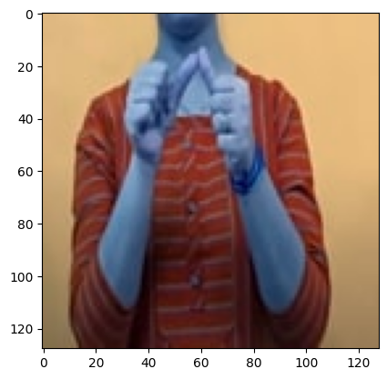

Figure 42 Resizing image (100X100)

Figure 31 RGB of image

Figure 30 Normal image(BGR)

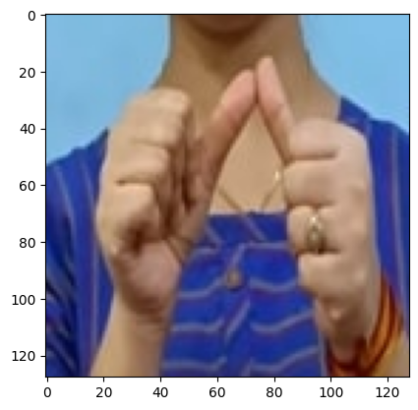

Figure 43 Segmentated portion of image

## 6.2 Attribute Selection

* Using MediaPipe Hand landmarks for hand sign recognition involves selecting and utilizing specific landmarks (key points) detected on the hand to characterize and recognize different signs or gestures. By extracting and analyzing these landmarks

### 6.2.1 Landmark Identification:

MediaPipe utilizes its hand tracking model to detect and identify key landmarks on the hand. These landmarks typically include:

* **Fingertips:** Points located at the tips of each finger.
* **Joints:** Points representing the knuckles or joints along each finger and the palm.
* **Palm Center:** Central point within the palm region.
* **Wrist:** Point at the base of the hand, near the wrist.
* Each landmark is represented by its 3D coordinates (x, y, z) in the image frame, providing spatial information about the hand's pose and configuration.
* Accurate landmark detection is crucial as it forms the foundation for subsequent feature extraction and gesture recognition.
* The precise localization of these landmarks enables the system to capture the intricate details of hand movements and configurations necessary for recognizing diverse hand signs.

### 6.2.2 Feature Extraction:

Once the landmarks are identified, various features can be extracted to characterize the hand and its gestures:

* Distances between Landmarks: Measure the Euclidean distances between pairs of landmarks (e.g., between fingertips, between joints).
* Angles Between Joints: Calculate the angles formed by three consecutive landmarks (e.g., angles between fingers, angles between fingers and palm).
* Relative Positions: Capture the relative positions of landmarks with respect to each other or to the palm center.
* These features encode the spatial relationships and geometrical properties of the hand, capturing both static configurations (e.g., hand shape) and dynamic movements (e.g., gestures).
* Feature extraction transforms the raw landmark coordinates into a structured set of quantitative descriptors that can effectively represent different hand signs.
* These extracted features serve as the input for machine learning algorithms or pattern recognition techniques, enabling the system to learn and distinguish between different gestures based on learned feature patterns.

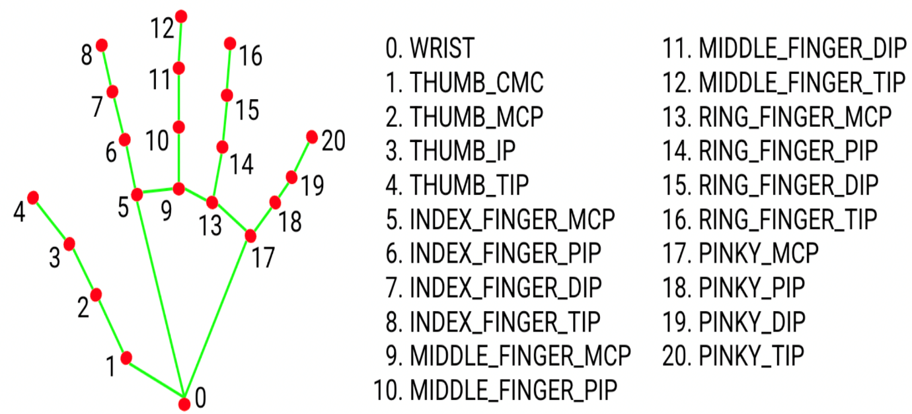

Figure 44 Landmarks using mediapipe

## 6.3 Model Training

### 6.3.1 Feature Extraction and Preparation :

* Features extracted from MediaPipe Hand landmarks, including distances between landmarks and angles at joints, serve as input variables for the Random Forest model. These features encode spatial relationships and configurations crucial for distinguishing between different hand signs.

### 6.3.2 Handling Multiple Hands with Padding :

* To accommodate scenarios with up to three hands in an image, padding techniques are implemented. This ensures consistent input dimensions across all samples, facilitating uniform processing by the Random Forest classifier.
* That means each sample have 3x42=126 features, but if we have a gesture using one hand only then rest 105 features will be consider as zero.

### 6.3.3 Test-Train Split :

* The dataset is split into training and testing sets using a standard test-train split method (e.g., 80% training, 20% testing). This allows for evaluating the model’s performance on unseen data, ensuring robustness and generalization.

### 6.3.4 Model Training :

* Random Forest, a supervised learning algorithm, is employed for training. It constructs multiple decision trees during training to classify hand signs based on the extracted feature patterns learned from the training data.
* Along with it various classification algorithms also tested for same data for comparison of results between them. Wherever required hyperparameter tuning is performed on these algorithms for better results.

## 6.4 Testing

* After training the model now we move to test our model. For this we have used train-test split. we have tested various ratios (90% - 10%, 80% - 20%, 70% - 30%, 60% - 40%, 50% - 50%) again for comparison among them with each algorithms.

## 6.5 Performance Measurement

* The model's performance is evaluated on the test set using metrics such as accuracy, precision, recall, and F1-score. These metrics quantify how well the model classifies hand signs across different algorithms.

### 6.5.1 Performance metrics :

* **Accuracy :** Classification accuracy is the accuracy we generally mean, whenever we use the term accuracy. We calculate this by calculating the ratio of correct predictions to the total number of input Samples.

$Accuracy = \frac{No. of correct prediction}{Total number of input sample for testing}$

* **Precision :** Precision is a measure of a model’s performance that tells you how many of the positive predictions made by the model are actually correct. It is calculated as the number of true positive predictions divided by the number of true positive and false positive predictions.
$$Precision = \frac{TP}{TP+FP}$$

* **Recall :** It is a metric that measures how often a machine learning model correctly identifies positive instances (true positives) from all the actual positive samples in the dataset.
$$Recall = \frac{TP}{TP+FN}$$

* **F1 – score :** It is a harmonic mean between recall and precision. Its range is [0,1]. This metric usually tells us how precise (It correctly classifies how many instances) and robust (does not miss any significant number of instances) our classifier is.
$$F1_score = \frac{2PR}{P+R}$$

* **Classification Report** : It is the report which explains everything about the classification. This is the summary of the quality of classification made by the constructed ML model. It comprises mainly 5 columns and (N+3) rows. The first column is the class label’s name and followed by Precision, Recall, F1-score, and Support. N rows are for N class labels and other three rows are for accuracy, macro average, and weighted average.

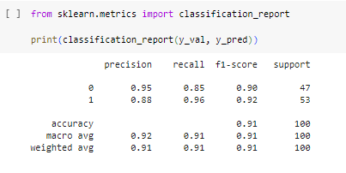

Figure 45 Classification Report

### 6.5.2 Comparison of Results:

* Results from each algorithm are compared to determine which one achieves the highest accuracy and reliability in recognizing hand signs. Comparison based on both accuracy with or without hyperparamter which also give us a brief information about which algorithm works without any external efforts.

### 6.5.3 Cross-Validation:

* To validate the robustness of the chosen algorithm, cross-validation techniques like k-fold cross-validation are applied. This helps in assessing the model's consistency and generalization ability across different folds of the dataset.
* **K-fold** : In K-Fold Cross Validation, we split the dataset into k number of subsets (known as folds) then we perform training on the all the subsets but leave one(k-1) subset for the evaluation of the trained model. In this method, we iterate k times with a different subset reserved for testing purpose each time. In the end we average all the result accuracies for overall performance of model on that dataset.

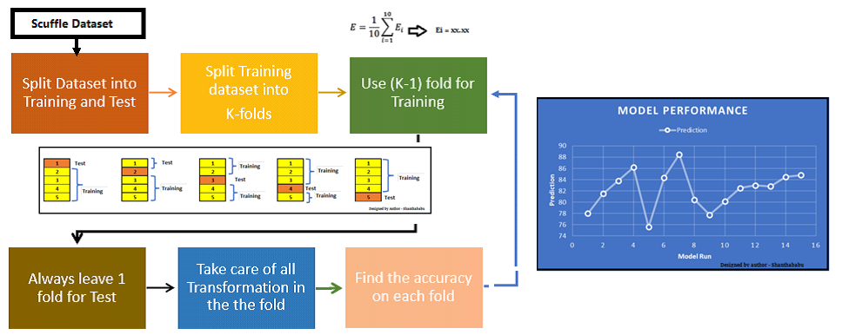

Figure 46 K-Fold

## 6.6 Model Selection

* Based on the evaluation metrics and cross-validation results, the most effective classification algorithm for hand sign recognition is selected. This algorithm demonstrates superior performance in accurately identifying and distinguishing between various gestures.

Figure 47 Comparison of result example

## 6.7 Real time Recognition

* Real-time recognition of hand signs using OpenCV frames, MediaPipe for landmark detection, and a trained classification model integrates these technologies seamlessly.
* OpenCV captures frames from a live video feed, which are then processed through MediaPipe's hand tracking module to detect and localize key landmarks on the hands in real-time.
* These landmarks serve as input to the trained classification model, which interprets the spatial configurations and gestures based on learned patterns from the training data.
* By leveraging MediaPipe's robustness in landmark detection and OpenCV's efficiency in frame handling, the system enables immediate interpretation of hand signs as the user interacts with the camera.

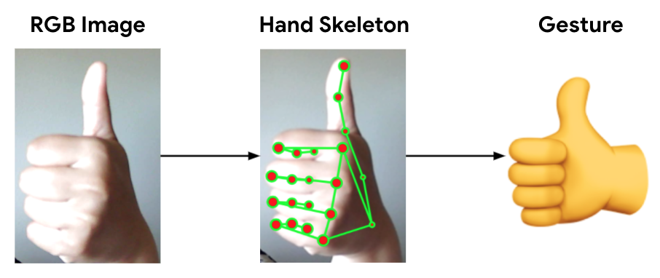

Figure 48 Real time recognition

# 7. DATASET

## 7.1 ISL Dataset from Kaggle

* The ISL (Indian Sign Language) dataset sourced from Kaggle comprises 26 classes, each representing a different sign corresponding to letters of the alphabet. This dataset includes 30 images per class, providing a foundational set of hand sign examples for initial training and testing.
* The images encompass variations in hand poses and environments, offering a diverse sample that aids in model learning and generalization.

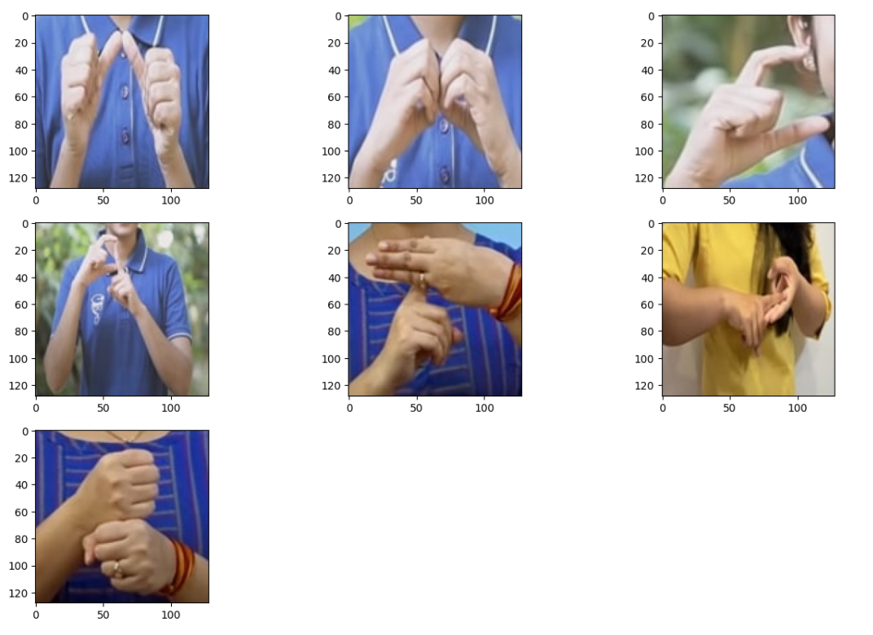

Figure 49 kaggle dataset

## 7.2 Custom Dataset

* To enhance the model's performance and generalization capabilities, a custom dataset was designed to enhance model performance, it includes diverse samples encompassing various demographics, hand poses, and environmental conditions such as different genders, age groups, lighting variations, and hand conditions (e.g., with gloves, dirty hands).
* This comprehensive dataset aims to improve accuracy and robustness in hand sign recognition tasks.

### 7.2.1 Alphabet Classes:

* **26 Classes :** Each representing a letter of the alphabet (A-Z).
* **150 Images per Class :** These images were carefully selected to include variations such as different genders, age groups, hand orientations, lighting conditions, and accessories like gloves. This diversity ensures robustness in recognizing hand signs under various real-world scenarios.

### 7.2.2 Number Classes:

* **10 Classes :** Representing numerical digits (0-9).
* **150 Images per Class :** Similar to the alphabet classes, these images encompass a range of variations to account for different contexts and conditions in which hand signs may be performed.

## 7.3 Dataset Characteristics

* **Diversity**: The custom dataset emphasizes diversity in its samples, encompassing variations in demographics (age, gender), environmental conditions (lighting, cleanliness of hands), and accessory usage (gloves). This diversity helps the model generalize better across different user profiles and conditions.
* **Balance :** Each class in both the alphabet and number categories is balanced with 150 images, ensuring equal representation during training to prevent biases towards more frequently occurring scenarios.
* **Enhanced Performance :** By supplementing the ISL dataset with a larger and more diverse custom dataset, the model benefits from improved performance in real-world applications, such as sign language translation systems or gesture-based interfaces.

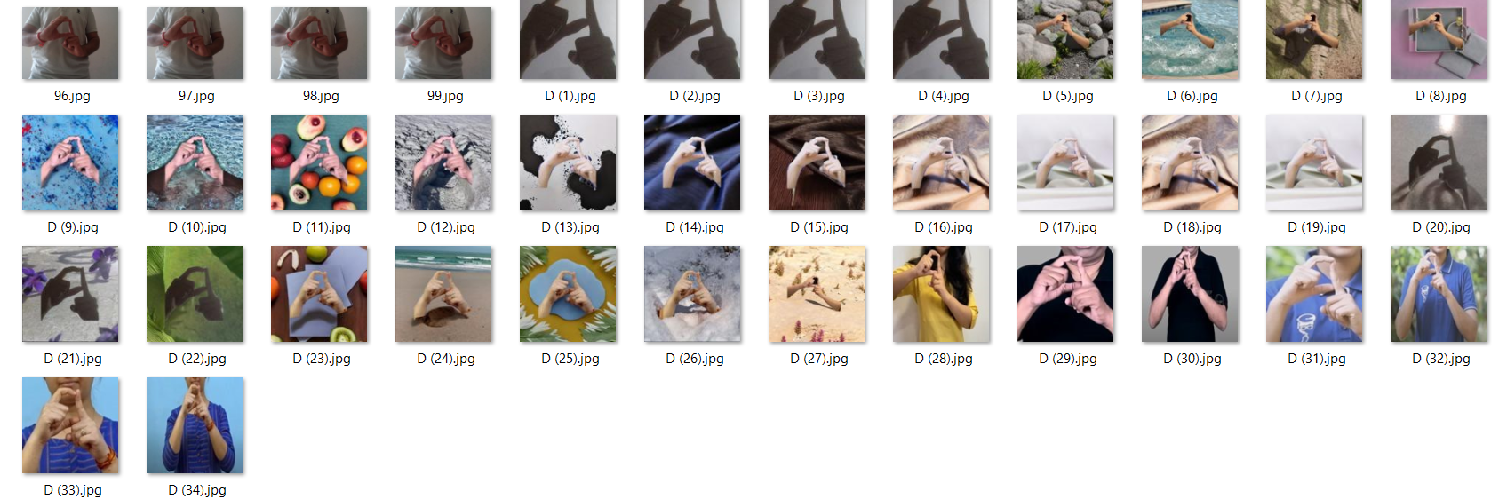

Figure 50 Custom dataset

# 8. IMPLEMENTATION

## 8.1 Data Collection

* We have created custom dataset to cover variations in demographics (age, gender), environmental conditions (lighting, cleanliness of hands), and accessory usage (gloves).

**Purpose:**

* The initial step in building a hand gesture recognition system is to gather a dataset of images that represent different hand gestures. These images serve as the raw data for training the machine learning model.

**Process:**

* **Directory Setup:** The script initializes a directory (./data_new) where the captured images will be stored. This directory is created if it doesn't exist.
* **Capturing Images:** Using a webcam (cv2.VideoCapture), the script captures images in real-time. Each image corresponds to a specific hand gesture, represented by a class label (e.g., 'A', 'B', ..., '9').

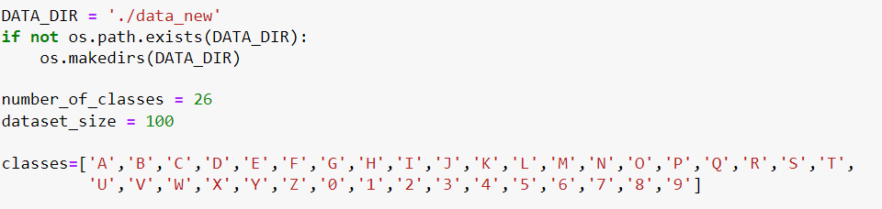

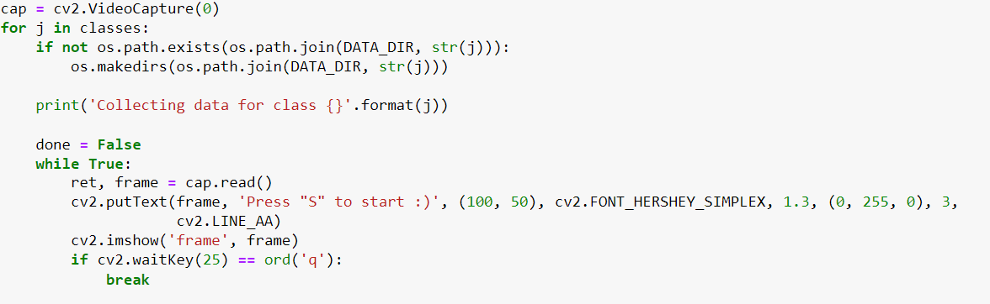

* **User Interaction:** Before capturing begins, the script displays a message prompting the user to press 'S' to start capturing images for each class. This interaction ensures that images are captured intentionally for each gesture.
* **Saving Images:** Once the capture starts, images are saved in respective subdirectories (./data_new/A, ./data_new/B, ..., ./data_new/9) until the desired dataset size (dataset_size) is reached for each class.

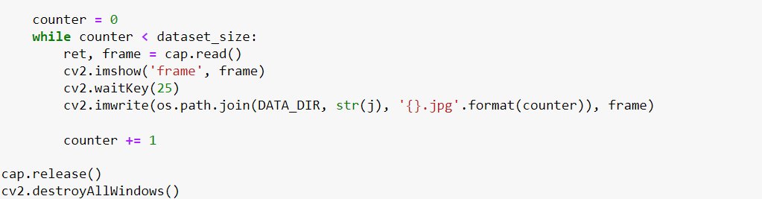

**Tools and Techniques used:**

* **OpenCV (cv2):** Used for accessing the webcam, capturing frames, and saving images.
* **File Handling (os): Manages directory creation (os.makedirs) and checks if directories exist (os.path.exists).**

## 8.2 Hand Landmarks Extraction and Dataset Creation

**Purpose:**

* Once images are captured, the next step is to extract meaningful features from these images. For hand gesture recognition, identifying and extracting hand landmarks (specific points on the hand) is crucial.

**Process:**

* **Loading Images:** The script loads each captured image from the directory structure (./data_new/A/*.jpg, ./data_new/B/*.jpg, ..., ./data_new/9/*.jpg).
* 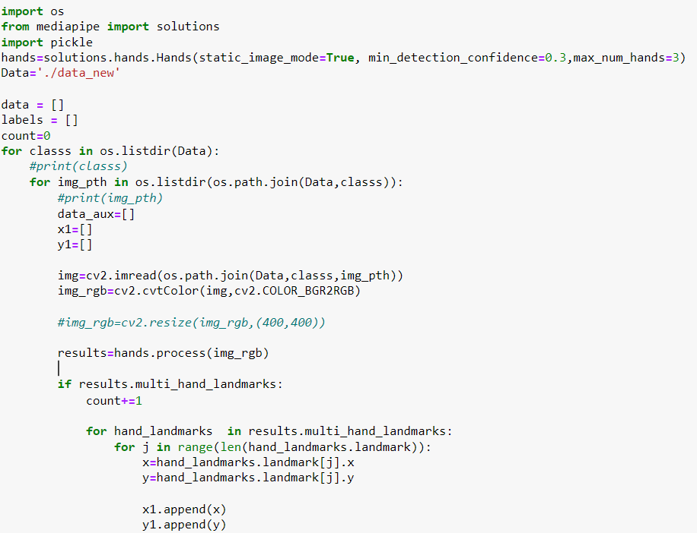**Hand Landmark Detection:** Using MediaPipe's Hands model (mp.solutions.hands.Hands), the script processes each image to detect hand landmarks. These landmarks represent key points on the hand, such as fingertips, joints, and palm center.
* **Normalization:** Detected landmarks are normalized to a consistent coordinate space relative to the hand's position and size in the image. Normalization ensures that variations in hand size and position do not affect the model's ability to learn from the data.
* **Data Preparation:** For each image:
  + Extracted hand landmarks (normalized coordinates) are stored in a structured format (e.g., lists or arrays).
  + Corresponding class labels ('A', 'B', ..., '9') are also recorded to associate each set of landmarks with its respective gesture.
* **Dataset Compilation:** All processed data (hand landmarks and labels) are collected into lists or arrays and saved into a serialized format using Python's pickle module (data.pickle). This file will be used in the next step for training the machine learning model.

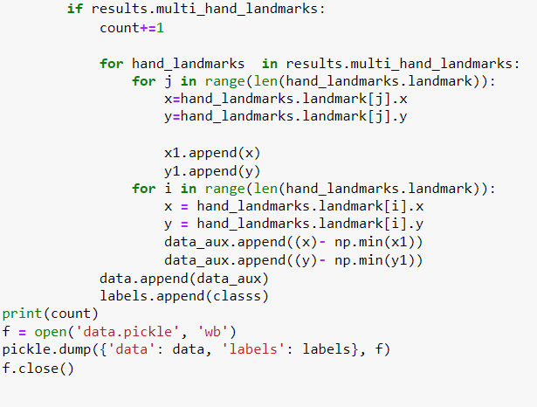

**Tools and Techniques used:**

* **MediaPipe :** Provides a pre-trained model (Hands) for accurate and efficient hand landmark detection.
* **Normalization:** Ensures consistency in input data by adjusting landmarks relative to the hand's position and size in each image.
* **Serialization (pickle):** Efficiently stores Python objects (lists, arrays) as binary data, preserving their structure for later use in model training.

## 8.3 Model Training

**Purpose:**

* With the dataset prepared and landmarks extracted, the next phase involves training a machine learning model to recognize hand gestures based on these extracted features.

**Process:**

* **Loading Dataset:** The script loads the preprocessed data from data.pickle, which includes normalized hand landmarks and corresponding class labels.
* **Data Preprocessing:**
  + First we convert the input image into RGB format and resize it to the same size as of our training data.
  + If necessary, sequences of hand landmarks are padded or truncated to ensure a fixed length. This step standardizes the input size required by the machine learning model. As it may possible that our gesture require only one hand.
  + The dataset is split into training and testing sets (train_test_split). This separation allows for evaluating the model's performance on unseen data.

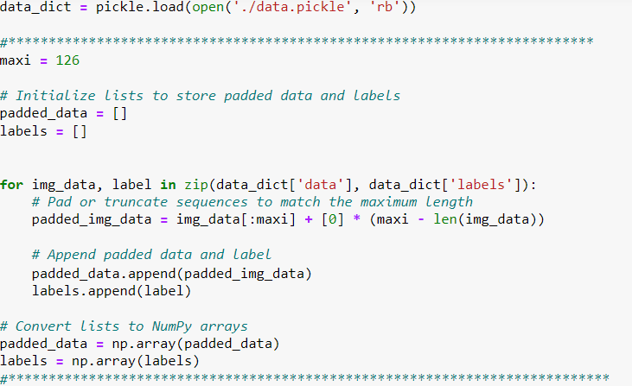

* **Model Selection:**
  + We have used a number of classification algorithms and based on the comparison of their result we decided to train our model with Random Forest Classifier.
  + A Random Forest classifier (RandomForestClassifier from sklearn.ensemble) is chosen for its ability to handle multiple classes and robustness against overfitting.
  + The classifier is initialized with default parameters and while comparing result it shows similar result with hyperparamter tuning as well. Depending on the dataset size and complexity, hyperparameter tuning might be necessary for optimal performance but result with random forest will not change significantly.
* **Training :** The Random Forest model is trained on the training set (x_train, y_train) using the fit method. This process involves learning the relationships between input hand landmarks and their corresponding gesture labels.
* **Model Evaluation :** After training, the model's performance is evaluated on the test set (x_test, y_test).Metrics such as accuracy (accuracy_score from sklearn.metrics) are computed to measure how well the model generalizes to new, unseen hand gestures.
* **Model Serialization:** Once trained and evaluated, the trained model (model) is serialized and saved to a file (model.p) using pickle. This file contains the trained model object, which can be loaded and used for real-time prediction.

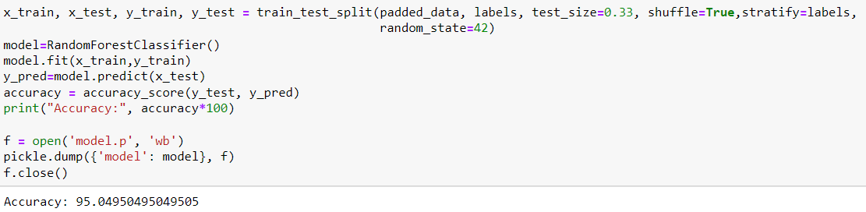

**Tools and Techniques used:**

* **Sklearn (sklearn):** Provides tools and algorithms for building and evaluating machine learning models.
* **Model Selection:** Random Forest chosen for its suitability for multi-class classification tasks and resistance to overfitting.
* **Evaluation metrics :** Accuracy is used to evaluate the performance.
* **Serialization (pickle):** Saves the trained model as binary data, preserving its structure and parameters for deployment in real-time prediction.

## 8.4 Real-time Prediction

**Purpose:**

* The final step in the system is deploying the trained model to make real-time predictions of hand gestures from a live webcam feed.

**Process:**

* **Loading Trained Model:** The script loads the serialized model (model.p) from the file. This model contains all the information learned during training and is ready to make predictions.
* **Webcam Setup:**
  + It initializes the webcam (cv2.VideoCapture) to capture live video frames.
  + MediaPipe's Hands model (mp.solutions.hands.Hands) is used to detect hand landmarks in real-time.

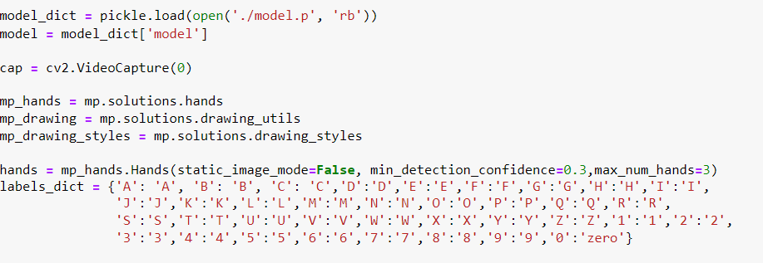

* **Prediction Loop:**
  + The script continuously captures frames from the webcam and processes each frame to detect hand landmarks using MediaPipe.
  + Detected landmarks are normalized similarly to the training phase to ensure consistency in input data.
* **Inference:**
  + The normalized hand landmarks are passed into the loaded model (model.predict) to predict the corresponding hand gesture (character).
  + A dictionary (labels_dict) maps predicted labels to meaningful gesture descriptions (e.g., 'A' to 'Z', '0' to '9').

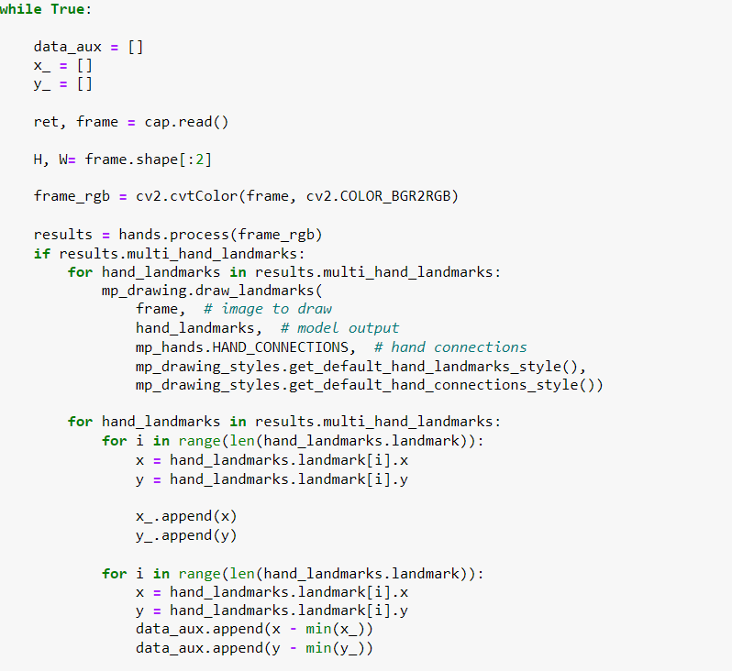

* **Visualization:** Predicted gestures are overlaid onto the webcam feed using OpenCV (cv2.putText, cv2.rectangle), providing real-time feedback to the user.
* **Termination:**The application continues to run until the user presses 'q' to quit. Upon termination, the webcam feed is released (cap.release()) and all OpenCV windows are closed (cv2.destroyAllWindows()).

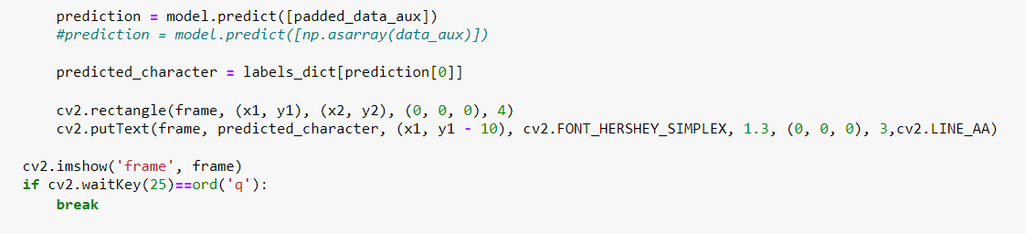

**Tools and Techniques used:**

* **Real-time Processing:** Efficiently processes video frames to ensure smooth performance and timely predictions.
* **User Interface:** Provides visual feedback (predicted gestures overlaid on the webcam feed) for interactive use.
* **Integration:** Combines computer vision (MediaPipe for hand landmark detection) and machine learning (trained model for gesture recognition) seamlessly for real-world application.

# 9. TESTING

* For electing best algorithm for our model, we have implemented a variety of classification algorithms to explore their effectiveness in solving the problem at hand.
* The algorithms include K-Nearest Neighbors (KNN), Support Vector Machine (SVM), Random Forest, Decision Tree, Naive Bayes, AdaBoost, and Bagging. Each algorithm was tested both with its default settings and after performing hyperparameter tuning. Before this we have tested each with various train-test ratios.
* This approach allowed me to compare their performances in terms of accuracy, robustness, and computational efficiency. By experimenting with different tuning parameters such as the number of neighbors in KNN, the choice of kernel in SVM, and the number of trees in Random Forest, We aimed to optimize their respective performances.
* 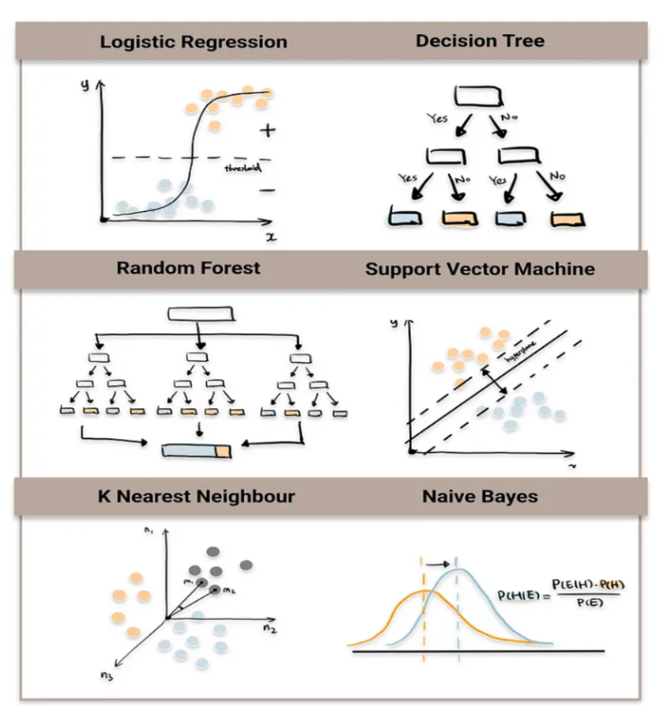 The results provided valuable insights into the strengths and weaknesses of each algorithm under different conditions, informing the selection of the most suitable model for the application.

## 9.1 Train-Test Split :

* + We train and test our dataset by using the train-test ratio 90-10, 80-20 , 70-30, 60-40, 50-50.

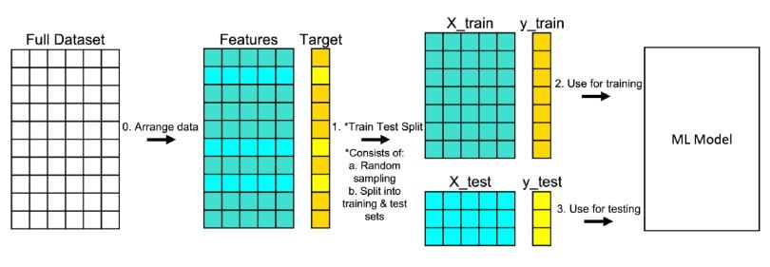

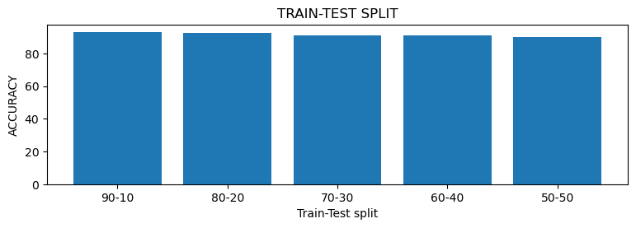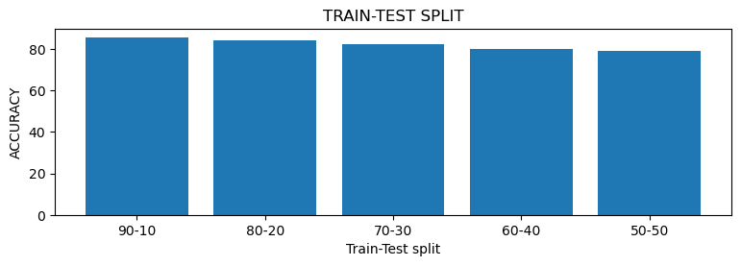

DECISION TREE :

KNN :

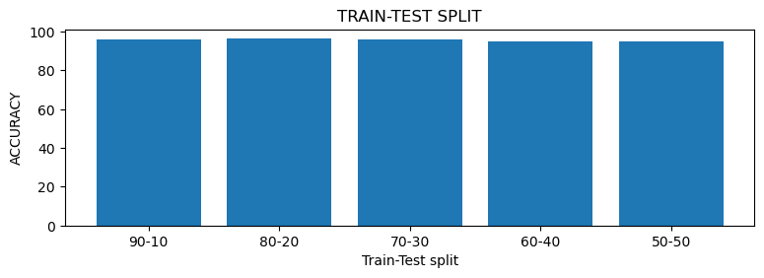 SVM :

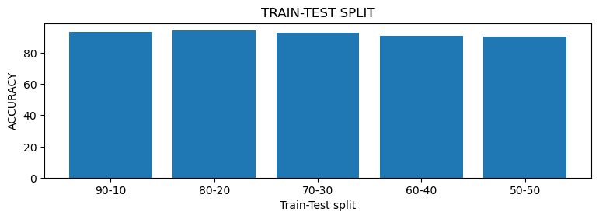 RANDOM FOREST :

NAÏVE BAYES:

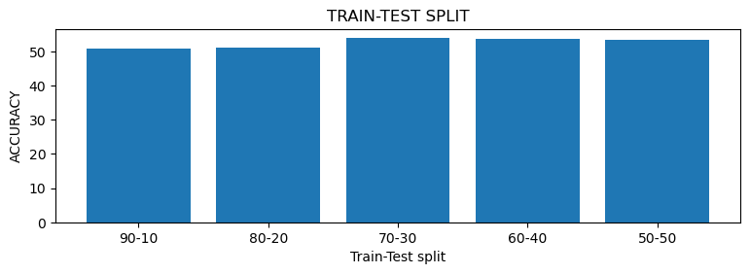

BAGGING :

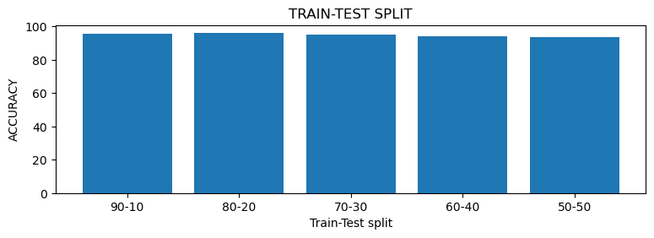BOOSTING :

## 9.2 KNN Model :

Classification report :

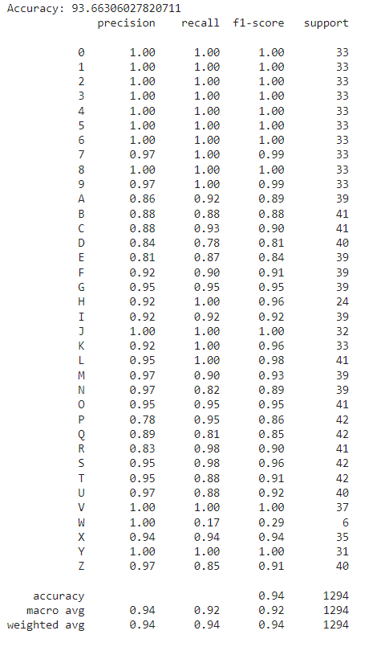

## 9.3 Decision Tree

Classification report :

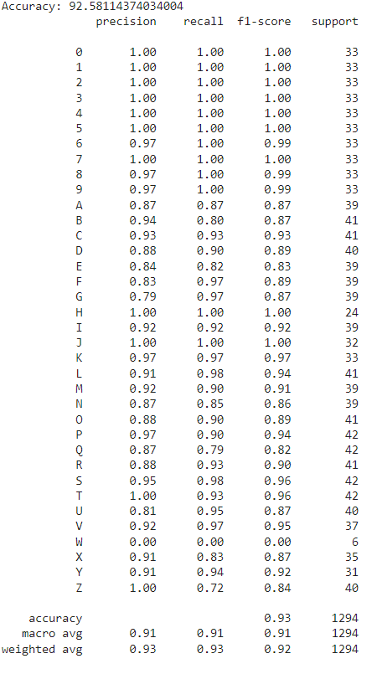

## 9.4 SVM :

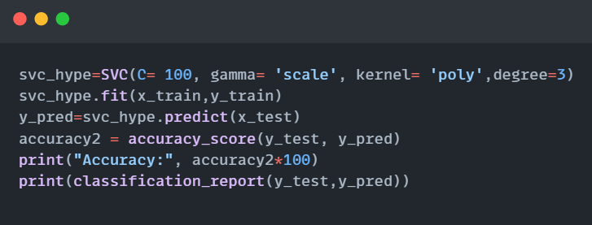

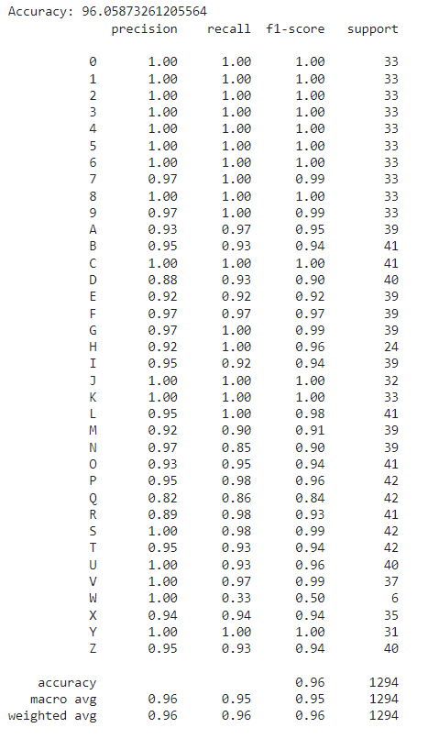Classification report :

## 9.5 Random Forest :

Classification report :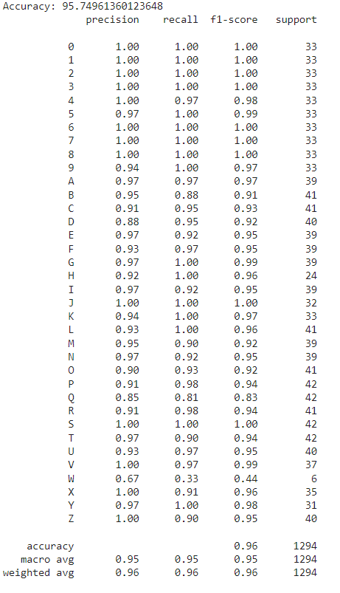

## 9.6 Naïve Bayes :

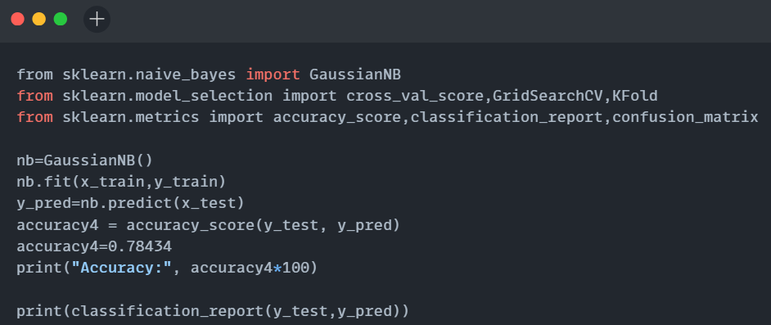

Classification report :

## 9.7 Bagging

Classification report :

## 9.8 Adaboost

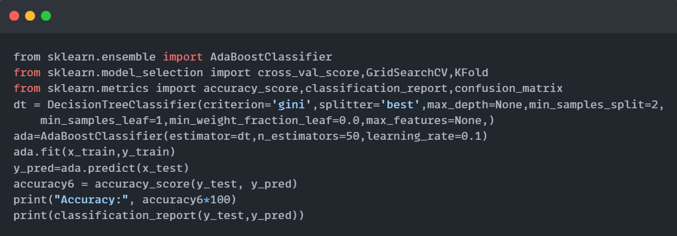

Classification report :

## 9.9 Real Time Recognition

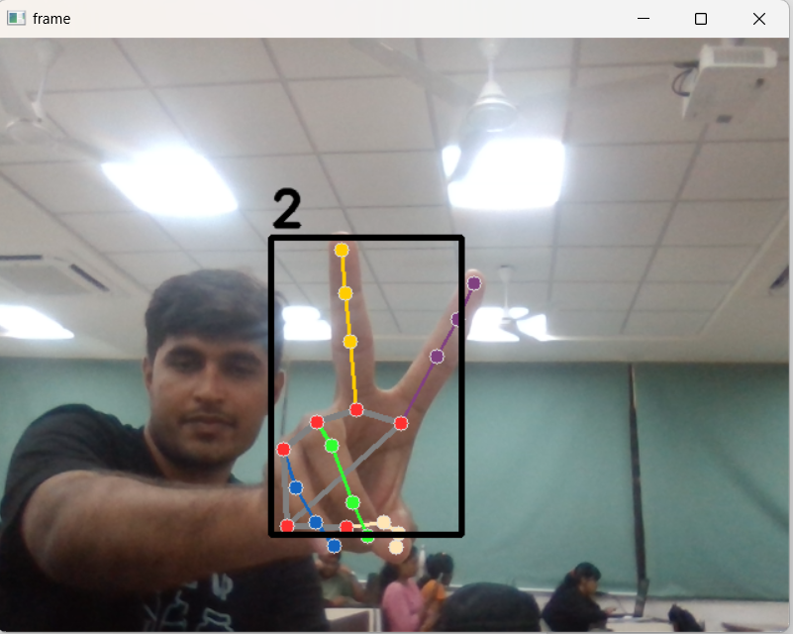

Figure 51 Real time recognition

# 10. RESULT AND DISCUSSION:

* In this study, we explored the application of various machine learning algorithms for the classification task using the dataset. The models evaluated include K-Nearest Neighbors (KNN), Decision Tree, Support Vector Machine (SVM), Random Forest, Naive Bayes, and Bagging. Each model was assessed based on accuracy, precision, recall, and F1-score metrics.

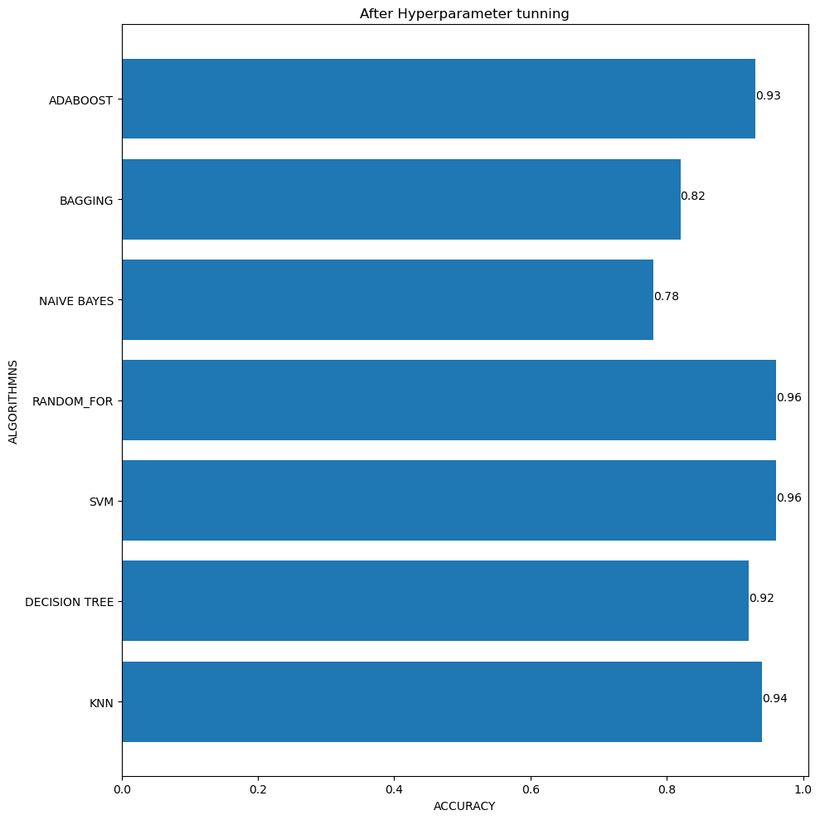

Figure 52 results before tuning

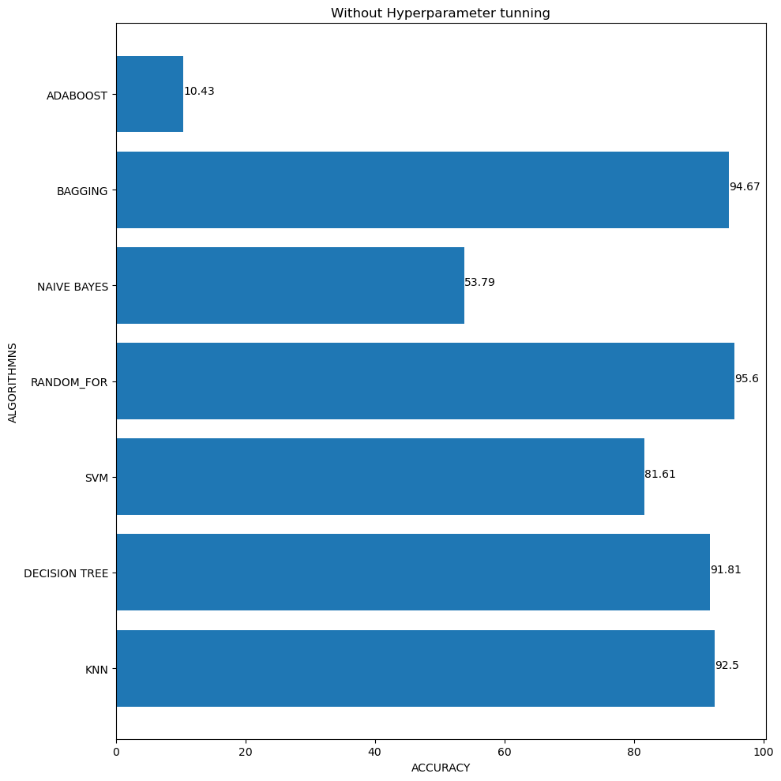

Figure 53 result after tunning

* K-Nearest Neighbors (KNN) achieved an accuracy of 91.39%. It demonstrated strong performance across most classes, particularly excelling in precision and recall for classes like '1', '6', '9', and 'J'. The model's ability to classify based on nearest neighbors proved effective, although it exhibited lower precision for certain alphanumeric characters.
* Decision Tree, optimized through hyperparameter tuning, achieved an accuracy of 91.39%. The model performed well in distinguishing between classes like '1', '6', and '9', showing improved precision and recall compared to the base KNN model. However, it struggled with precision in classes 'A', 'D', 'L', and 'W', indicating potential overfitting or underfitting issues with the selected hyperparameters.
* Support Vector Machine (SVM) outperformed other models with an accuracy of 93.91%. SVM showed robust performance across most classes, achieving high precision and recall for classes '1', '6', '9', 'B', and 'Q'. This model's ability to handle complex decision boundaries and high-dimensional data was evident in its superior performance.
* Random Forest yielded an accuracy of 95.13%, making it the top-performing model in this study. Its ensemble approach leveraged multiple decision trees to mitigate overfitting and enhance accuracy. Random Forest excelled in precision and recall across various classes, demonstrating consistent performance and effectively handling the dataset's complexity.
* Naive Bayes achieved an accuracy of 78.43%, showing moderate performance compared to the other models. While it demonstrated high precision and recall for some classes like '1', '6', and '9', it struggled with classes such as 'A', 'C', 'D', and 'M', indicating limitations in handling dependencies among features.
* Bagging and Boosting, implemented with SVM and decision tree respectively as the base estimator, achieved an accuracy of 88.80% and 95%. It improved upon the SVM base model's performance in some classes but exhibited challenges in precision for classes like 'E', 'J', and 'L'. Bagging's ensemble method provided robustness but did not consistently outperform the SVM model alone. Boosting with decision tree also have the same result.

## Best Algorithm :

* We have concluded that the Random Forest model emerged as the most effective classifier for this dataset, achieving the highest overall accuracy among the models tested.
* SVM also showed strong performance, highlighting its suitability for complex classification tasks. Each model's strengths and weaknesses provide valuable insights for future improvements and applications in similar classification tasks.
* Further optimization and feature engineering could potentially enhance the performance of these models in real-world applications.

# 11. CONCLUSION

* In this study, we conducted a comprehensive evaluation of various machine learning algorithms for the classification of alphanumeric characters using a dataset of handwritten characters.
* Our analysis focused on assessing the performance of K-Nearest Neighbors (KNN), Decision Tree, Support Vector Machine (SVM), Random Forest, Naive Bayes, and Bagging models based on accuracy, precision, recall, and F1-score metrics.
* Among the models evaluated, Random Forest emerged as the most effective classifier, achieving an accuracy of 95.13%. Its ensemble approach effectively mitigated overfitting and demonstrated robust performance across a wide range of alphanumeric classes. Support Vector Machine (SVM) also delivered strong results with an accuracy of 93.91%, highlighting its capability to handle complex decision boundaries and high-dimensional data.
* In conclusion, while our study achieved promising results with Random Forest and SVM models, addressing the dataset's challenges and refining model limitations remain critical for advancing the accuracy and reliability of handwriting recognition systems. Future research could explore larger and more diverse datasets, employ advanced preprocessing techniques, and investigate ensemble methods tailored to specific characteristics of handwritten characters to further enhance classification performance in practical applications.

# 12. REFERENCES :

[1] A. Babour *et al.*, ‘Intelligent gloves: An IT intervention for deaf-mute people’, *J. Intell. Syst.*, vol. 32, no. 1, 2023, doi: 10.1515/jisys-2022-0076.

[2] M. Alaftekin, I. Pacal, and K. Cicek, ‘Real-time sign language recognition based on YOLO algorithm’, *Neural Comput. Appl.*, vol. 36, no. 14, pp. 7609–7624, 2024, doi: 10.1007/s00521-024-09503-6.

[3] M. Oudah, A. Al-Naji, and J. Chahl, ‘Hand Gesture Recognition Based on Computer Vision: A Review of Techniques’, *J. Imaging*, vol. 6, no. 8, 2020, doi: 10.3390/JIMAGING6080073.

[4] Yash Ramteke, Swapnil Thorat, Dhanashri Wani, Pushkar Chordiya, and Prof. J. S. Pawar, ‘Machine Learning-Based Hand Sign Recognition’, *Int. J. Adv. Res. Sci. Commun. Technol.*, pp. 654–659, 2023, doi: 10.48175/ijarsct-13193.

[5] S. Wang, K. Wang, T. Yang, Y. Li, and D. Fan, ‘Improved 3D-ResNet sign language recognition algorithm with enhanced hand features’, *Sci. Rep.*, vol. 12, no. 1, pp. 1–19, 2022, doi: 10.1038/s41598-022-21636-z.

[6] P. J. Nanajkar, ‘Hand Sign Language Recognition and Conversion into Text Using Convolutional Neural Network’, *Interantional J. Sci. Res. Eng. Manag.*, vol. 08, no. 01, pp. 1–13, 2024, doi: 10.55041/ijsrem28480.

[7] T. Sahana, S. Paul, S. Basu, and A. F. Mollah, ‘Hand sign recognition from depth images with multi-scale density features for deaf mute persons’, *Procedia Comput. Sci.*, vol. 167, no. 2019, pp. 2043–2050, 2020, doi: 10.1016/j.procs.2020.03.243.

[8] P. Moon *et al.*, ‘An improved custom convolutional neural network based hand sign recognition using machine learning algorithm’, *Eng. Reports*, no. January, pp. 1–15, 2024, doi: 10.1002/eng2.12878.

[9] K. Aghera, H. Pambhar, and N. Tada, ‘MMR-LEACH: Multi-tier multi-hop routing in LEACH protocol’, in *Advances in Intelligent Systems and Computing*, Springer Verlag, 2017, pp. 205–214. doi: 10.1007/978-981-10-2750-5_22.

[10] D. U. Gogate, V. Kazi, A. Jadhav, and T. Bari, ‘Hand Sign Recognition for Medical Field Genesis’, *Int. J. Res. Appl. Sci. Eng. Technol.*, vol. 10, no. 4, pp. 1794–1797, 2022, doi: 10.22214/ijraset.2022.41625.

[11] K. Aghera, H. Pambhar, and N. Tada, *MMR-LEACH: Multi-tier multi-hop routing in LEACH protocol*, vol. 508. 2017. doi: 10.1007/978-981-10-2750-5_22.

[12] P. Nakjai and T. Katanyukul, ‘Automatic Hand Sign Recognition: Identify Unusuality through Latent Cognizance’, pp. 1–13, 2021, [Online]. Available: http://arxiv.org/abs/2110.15542